Downloaded trom www.singapore-exam-papers.com

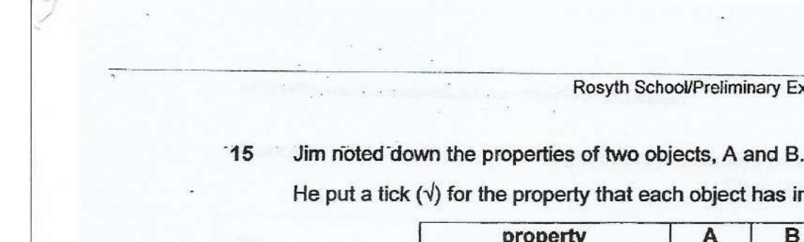



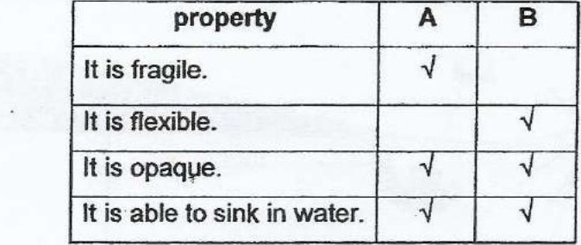

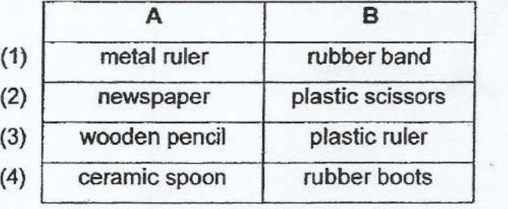

16 Bob placed an iron toy car on a board made from three different materials, X,  
Y and Z, which were glued together. He used a magnet to move the car from  
point A to point D. However, the car came to a stop at point C.

