Downloaded trom www.singapore-exam-papers.com

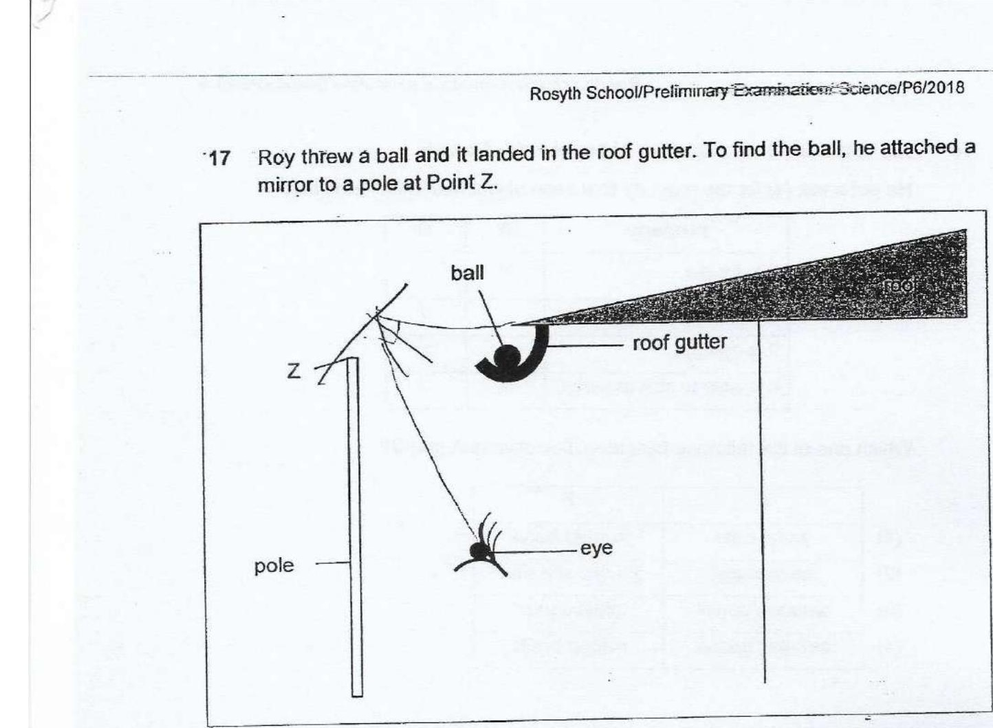



Which one of the following diagrams shows the correct position of the mirror that  
will allow Roy to see the ball in the gutter?

