Downloaded trom www.singapore-exam-papers.com

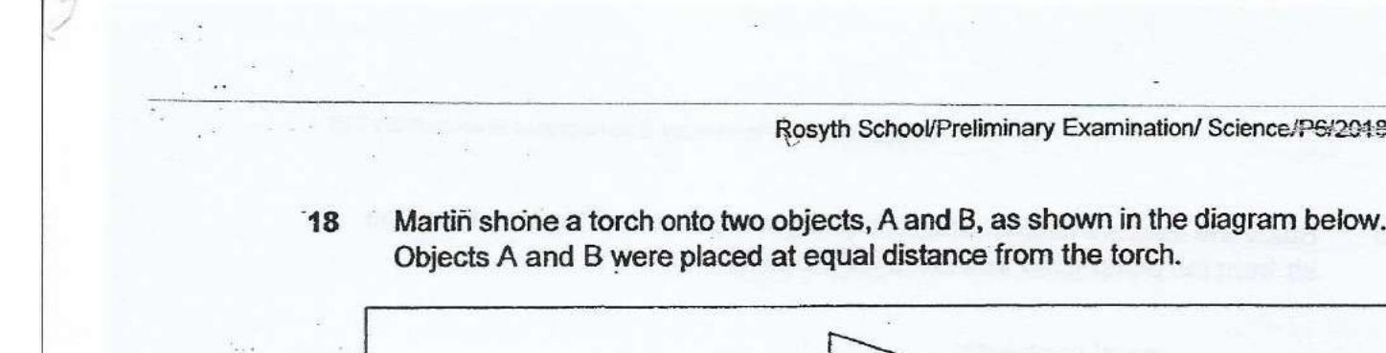



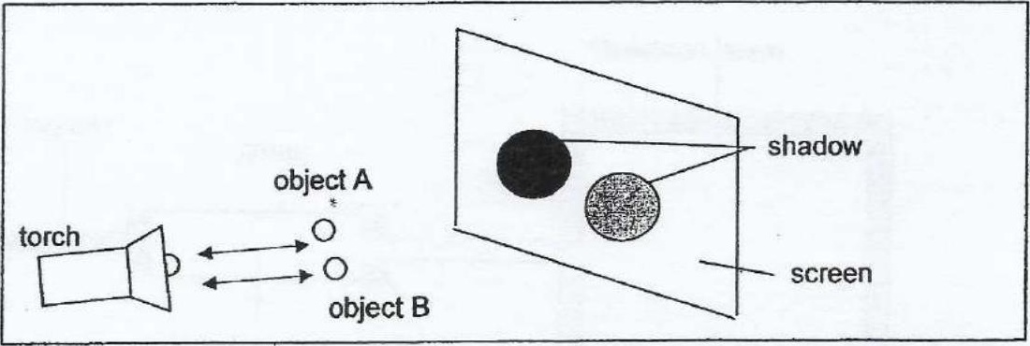

The shadows cast by objects A and B are of similar size but the shacow of object  
A is darker than the one cast by object B.

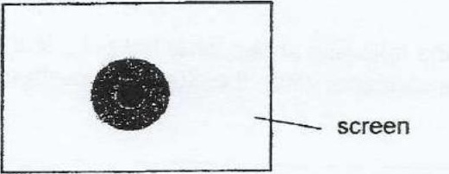

Which one of the following changes should he do before he aligns the objects in  
a straight line?

(1) Move object A nearer to the torcn  
  
(2) Move object A nearer to the screen .  
(3) Move object B nearer to the screen  
  
(4) Move objects A and B nearer to the torch