Downloaded trom www.singapore-exam-papers.com

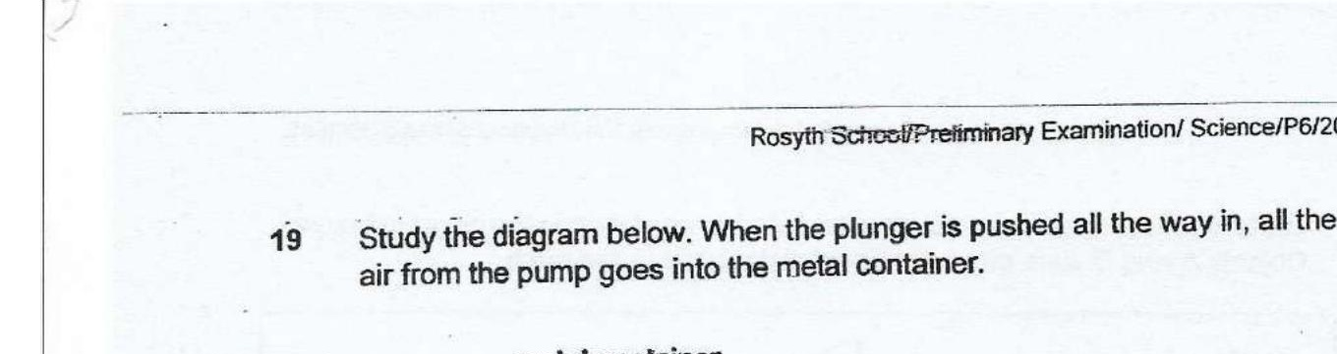



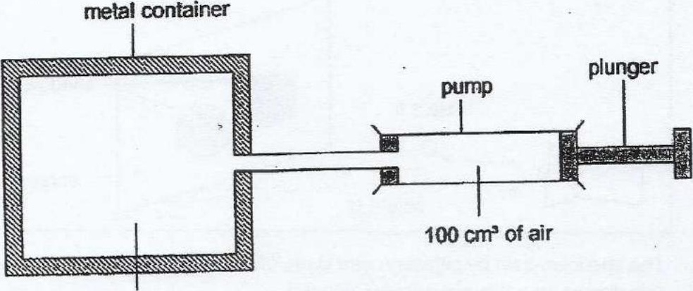



Which one of the following shows what happens to the volume and mass of  
air in the metal container when the plunger is pushed ail the way in?

