Downloaded trom www.singapore-exam-papers.com

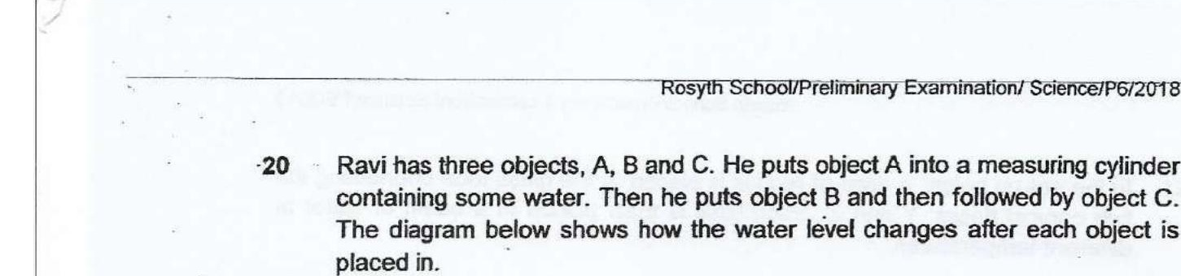

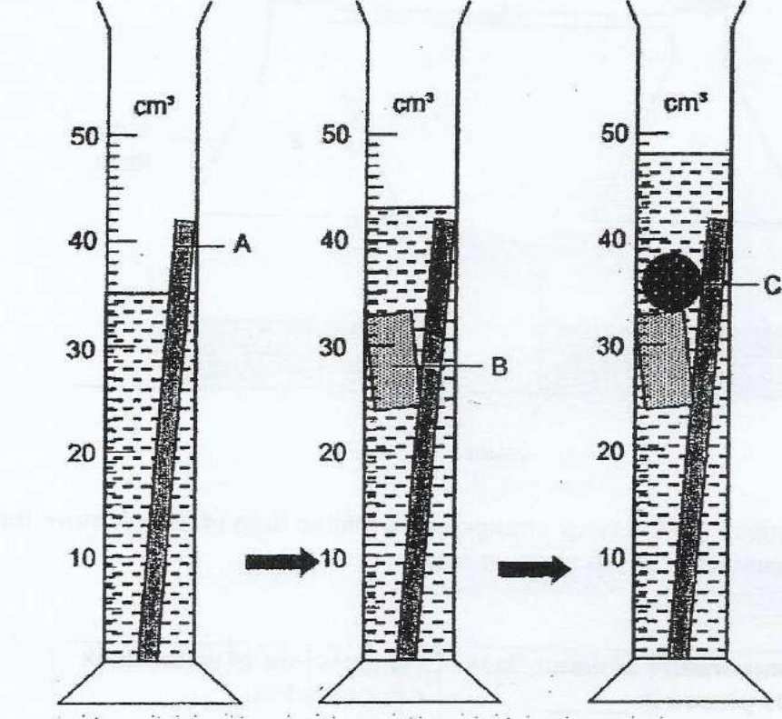



(1) C only  
  
(2) A only  
(3) B and C only  
(4) A, B and C