Downloaded trom www.singapore-exam-papers.com

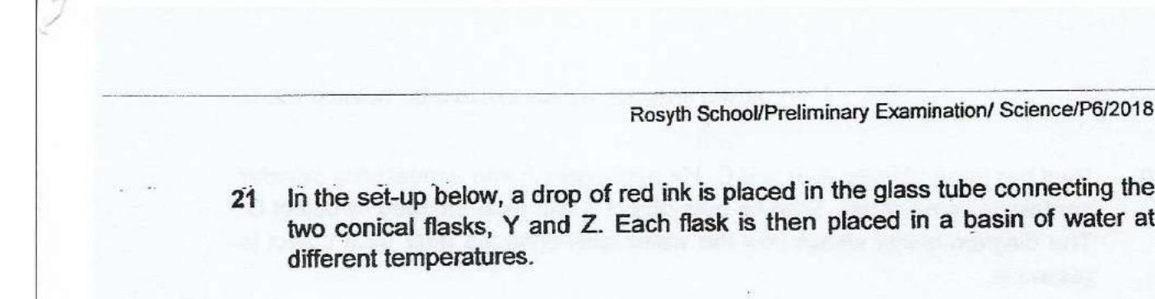



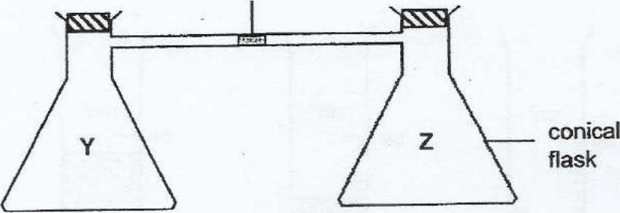

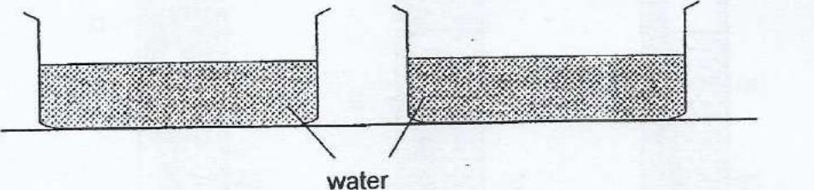

In which one of the following arrangements will the drop of red ink move the  
furthest from flask Z in the shortest time?

