Downloaded from www.singapore-exam-papers.com

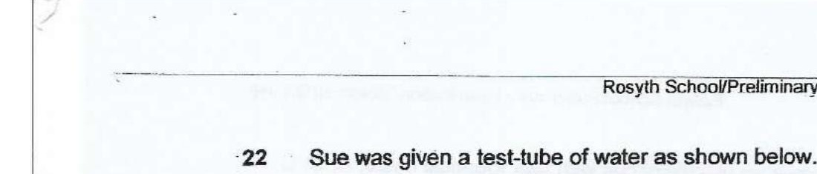

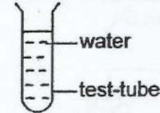

What should Sue do in order to allow the water in the test-tube to take a shorter  
time to evaporate?

(1) Remove alf fans at the location  
  
(2) Put an ice cube into the test-tube of water  
  
(3) Seal the mouth of the test-tube with plasticine  
(4) Transfer all the water from the test-tube to a tray

23 Minnie opened the freezer door and observed white ‘clouds escaping trom the  
freezer.

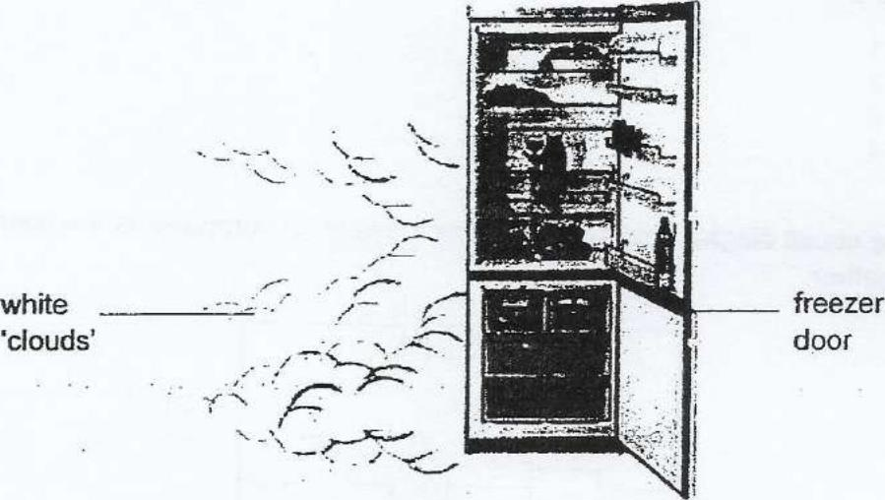

(1) The ‘clouds’ seen is steam formed during the process of condensation.  
  
(2) Water droplets from in the refrigerator evaporated to form the ‘clouds’.  
  
(3) Water vapour from the cold air lost heat to the warmer surrounding air and  
condensed to form the ‘clouds’.  
  
(4) Warmer water vapour from surrounding air lost heat to the cold air and  
condensed to form the ‘ciouds’.