Downloaded trom www.singapore-exam-papers.com

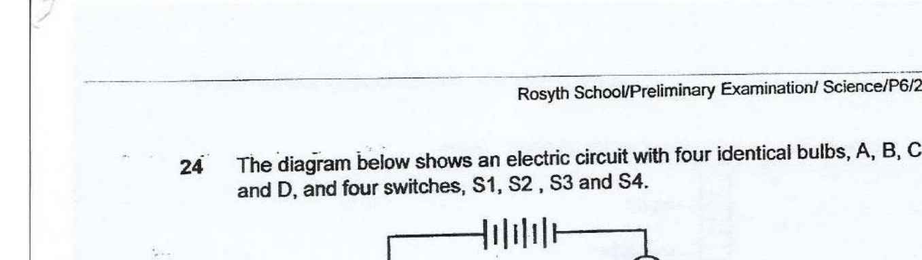



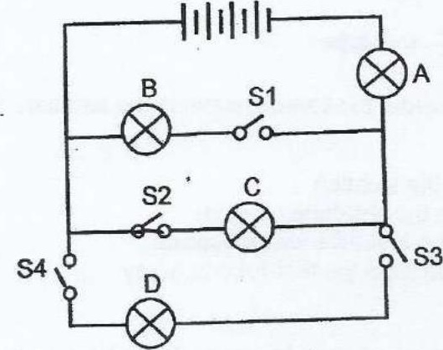

What is the least number of switches that must be closed to light up bulbs A

25 The circuit diagram below shows how the various components are connected  
together.

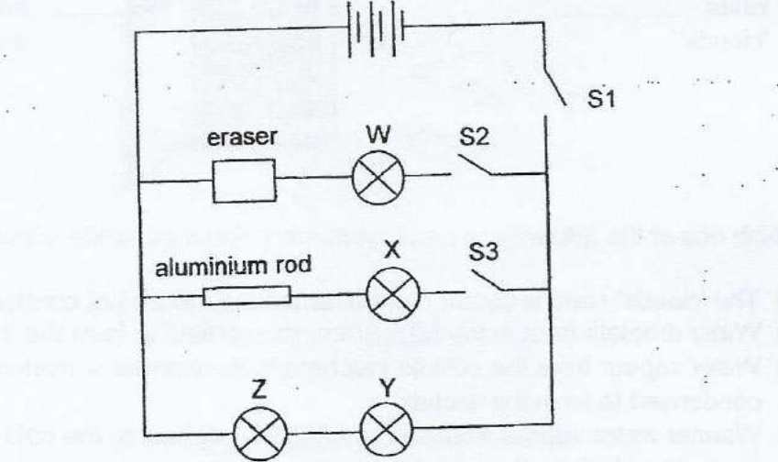

Which one of the following observations is correct?

(1) When only S1 and S2 were closed, bulb W was iit.  
  
(2) When only S1 was closed, all the bulbs were lit.  
  
(3) When only S3 was closed, bulbs X, ¥ and Z were lit.  
  
(4) When only S2 and S3 were closed, none of the bulbs lit up.