Downloaded trom www.singapore-exam-papers.com

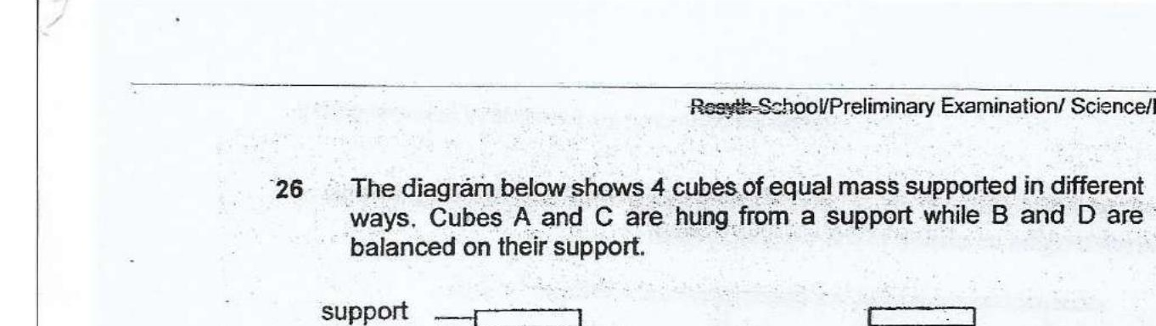



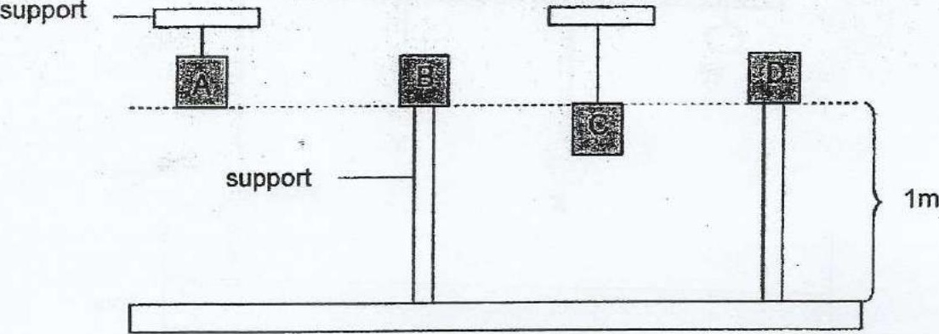

Which one of the following statements is true about the amount of  
gravitational potential energy the cubes possess?

(1) A is equal to B  
  
(2) A is greater than B  
  
(3) C is greater than D .  
  
(4) All the cubes have the same amount

27 When Aziz jumped on the trampoline, he noticed that there was a force  
which pulled him downwards and then another force which pushed him  
upwards.  
  
. _ . x ——~ Aziz  
. i . ‘

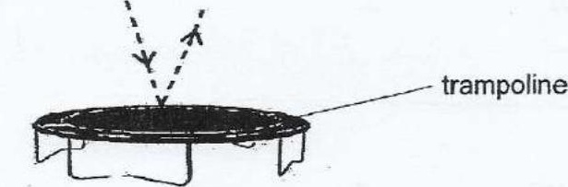

Identify the forces which pulled him downwards and pushed him upwards  
respectively.

