Downloaded trom www.singapore-exam-papers.com

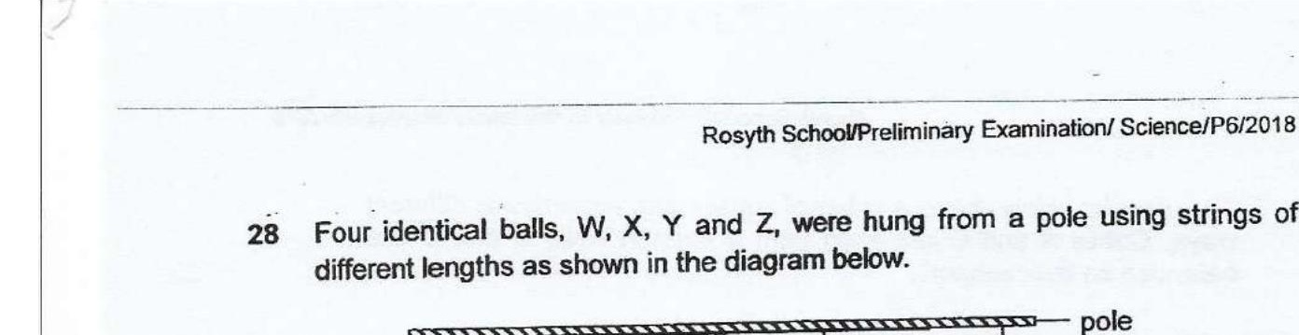



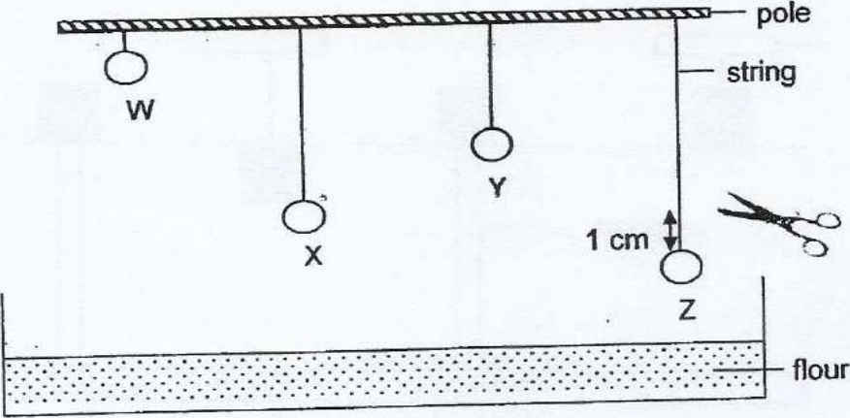

Each string was cut 1 cm above each ball. The balls landed in a container of  
flour placed directly below. Four dents of different depths were created in the  
flour by the four balls.

Which one of the following diagrams shows correctly the four dents in the flour  
made by the four balis respectively?

