Downloaded trom www.singapore-exam-papers.com





29 +A group of scientists studied the mass of similar type of dead leaves at two  
places M and N. Process A took place and the mass of leaves decreased over  
a period of five weeks. The fesults are as shown below.

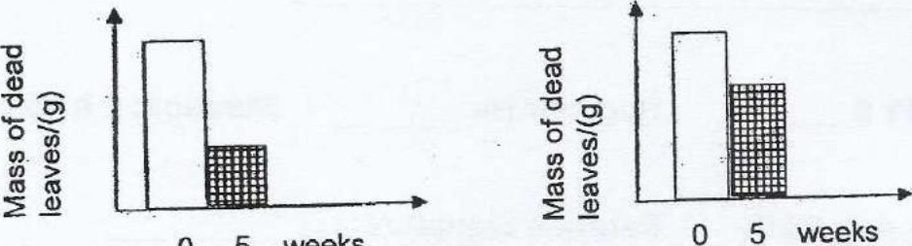



(a) Name the process A.

The mass of dead leaves decreased in both places over the period of 5 weeks.

(b) Explain how a physical factor in the environment has caused a difference in the  
decrease of mass of the dead leaves in the two places M and N. [2]

(c) Other than process A, evaporation could also cause the decrease in the mass  
of dead leaves. Explain why. (1)