Downloaded from www.singapore-exam-papers.com

30 David read adout an animal P In nis DOOK.

ba os  
Camere ries ee palin,  
SG ne ee  
se Se Pe  
ee  
nt ,

(a) Animal P ts a mammal. State a physical characteristic that helped fo classify it  
as amammal. {1]

Animal P lives near a river. The young of animal P are born in a burrow under  
the ground as shown below.

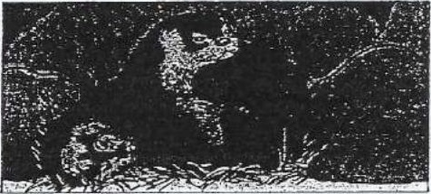

Animal P spends most of its time in water. If usually keeps Its feet above  
water as shown below. David predicted that this behaviour is to keep itself  
warm in a very cold water.





Question 30 3s continued on page 4