Downloaded trom www.singapore-exam-papers.com





To prove his prediction, David conducted an experiment using set-ups A and  
  
- B as shown below. A and B are double glass beakers, A filled with air in-  
between while B is filled with water. Both beakers filled with hot water at 80°C  
as shown below.

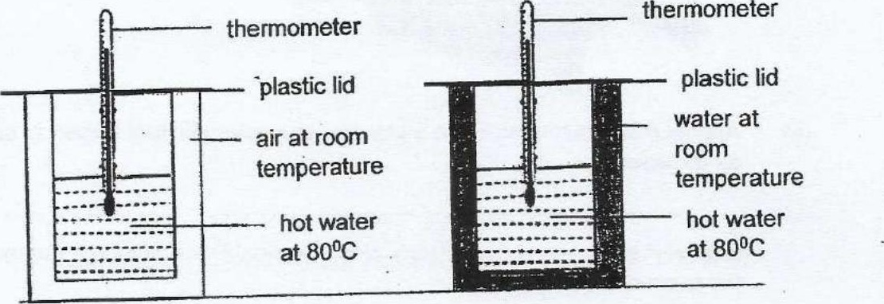

David measured the temperatures of the hot water in the beakers at different  
times and plotted his results in the graph stfown.

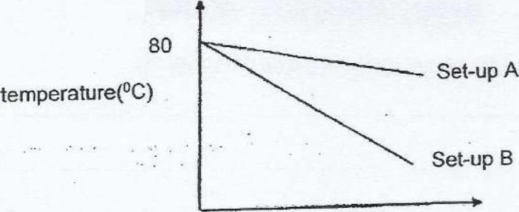

(c) Based on the graph, what is the relationship between the temperature of hot  
water and time? 11}

