Downloaded trom www.singapore-exam-papers.com





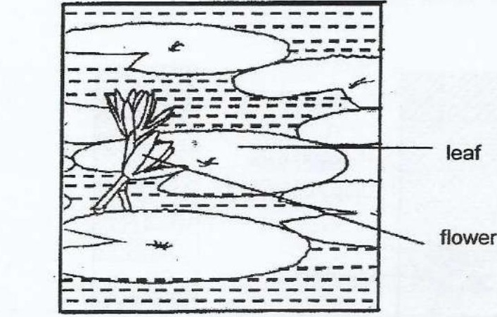

(a} Devi noticed that flowers of plant A were above the water.  
How does this characteristic help plant X in its reproduction? {1}

(ob) Complete the Doxes below to state the other part anc process involved for  
flowers of plant X to become fruits.

