Downloaded trom www.singapore-exam-papers.com





| 32 Wen Hui wanted to find out if oxygen is released by a water plant during  
photosynthesis. He set up an experiment as shown in the diagram below in a lit

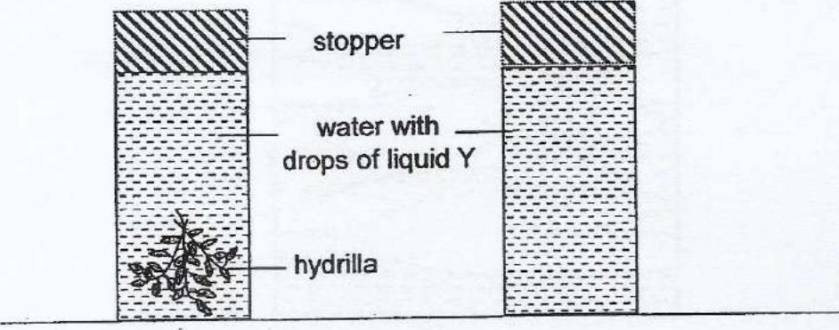



Liquid Y is used as an indicator of oxygen. It tums from blue to red when the  
amount of oxygen increases. The indicator was blue at the start of the  
experiment. °

(a) Why was the experiment conducted in a fit room?

(b). Wen Hui's friend said that Cylinder B was not needed for his experiment  
Do you agree with his friend? Explain why. {1]