Downloaded from www.singapore-exam-papers.com

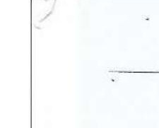



33 Rina measured ine amount of undigested food in each part of a human  
digestive system just before it entered the next part. She wanted to show the ,  
comparison of undigested food between the mouth and gullet using a  
graph.She drew two graphs, X and Y, as shown below.

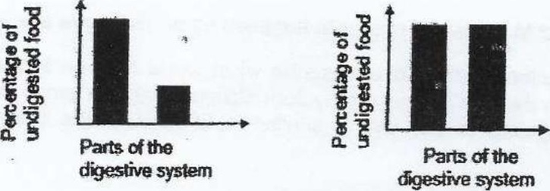

(a) | Which graph X or Y represents the comparison between the mouth and gullet  
correctly? Give a reason. {1}

(b) Besides the mouth and small intestine, which other part of the human  
digestive system produces digestive juice? [1]

Question 33 is continued on page &