Downloaded trom www.singapore-exam-papers.com

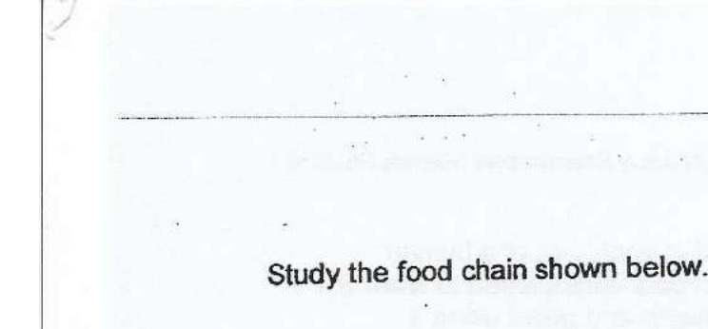





Aduit female insect M is always filled with fertilised eggs. The eggs are not digestible.

(c) Using the information above, describe what would happen to the insect and  
the eggs in the bird’s digestive system starting from the smaii intestine. The  
digestive system in the bird is similar in function to the human digestive  
system. {2]



Birds feed on many insects M before migrating to another place.

(d) | How does Insect M benefit from this relationship?