Downloaded from www.singapore-exam-papers.com

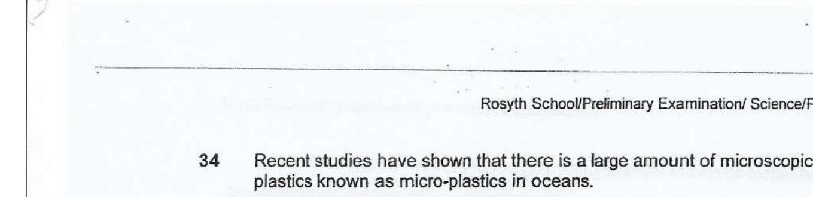

Study the food chain in a nabitat.

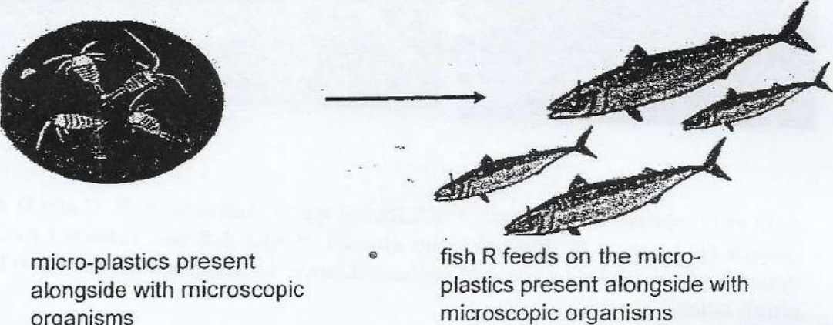

Animal 5 lives in the same habitat as the fish. A marine scientist found micro-  
plastics in the stomach of animal S.

(b) State a possible relationship between the fish R and animal 5 in the above  
food chain.