Downloaded trom www.singapore-exam-papers.com

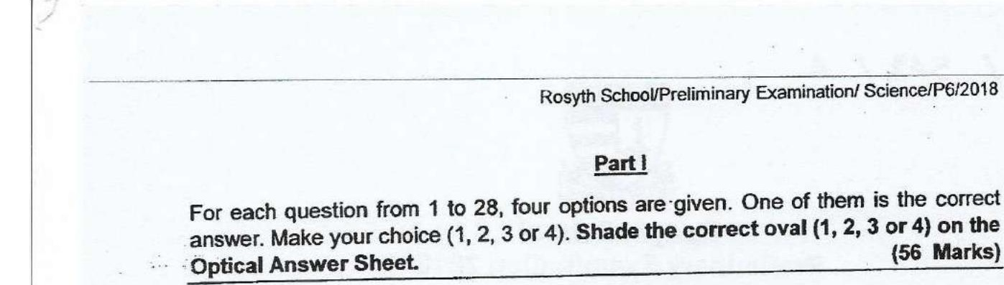



1 Which of the following characteristic is found in insects, but not in other  
animals?

(1) They lay eggs.  
  
(2) They have wings.  
  
(3} They have feelers.  
  
(4) They have three body parts.

2 The graph below shows the change in the population of zebras in a grassiand  
habitat over a petiod of time. Zebras feed on grass only.

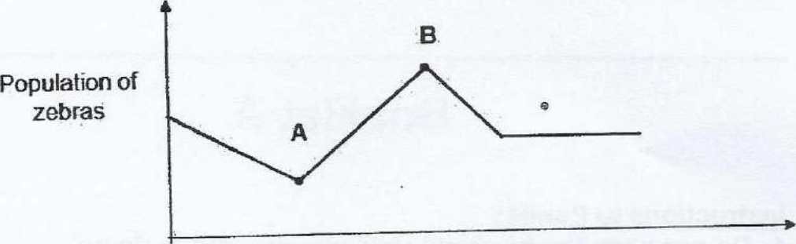

Which of the following events most likely could have fed to the change in the  
zebra population from Point-A to Point B? :

(1) There was a drought in the grassland.  
  
(2) There was an introduction of a new disease.  
  
(3) There was overeating of grass by animals in the grassland.  
  
(4) There was a decrease in the population of the zebra's predators.

3 Which of the following shows how the carbon dioxide is removed from a  
human body?







