Downloaded from www.singapore-exam-papers.com



35 Reflective studs are used to mark roads in unlit areas as shown below.

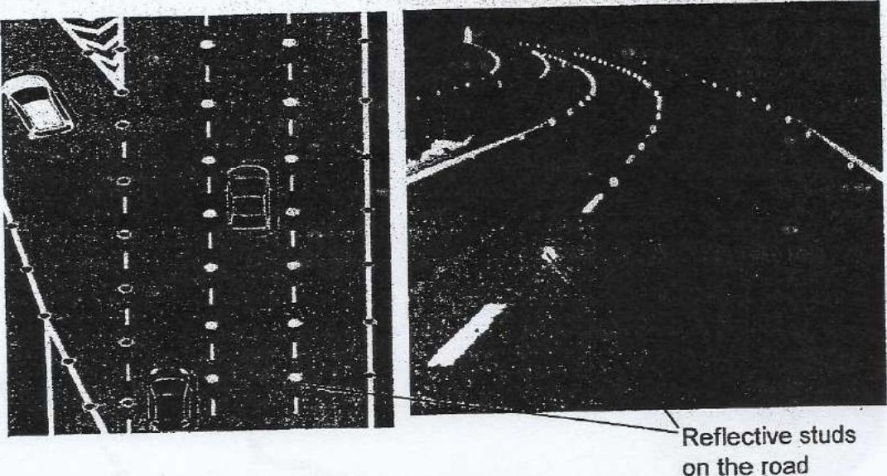

Ahmad conducted an experiment with four different materials, A, B, C and D. He  
  
2 used a light sensor to determine the amount of light that was reflected by the  
materials from the fight source at various distance. He recorded the results in the  
graph below. :

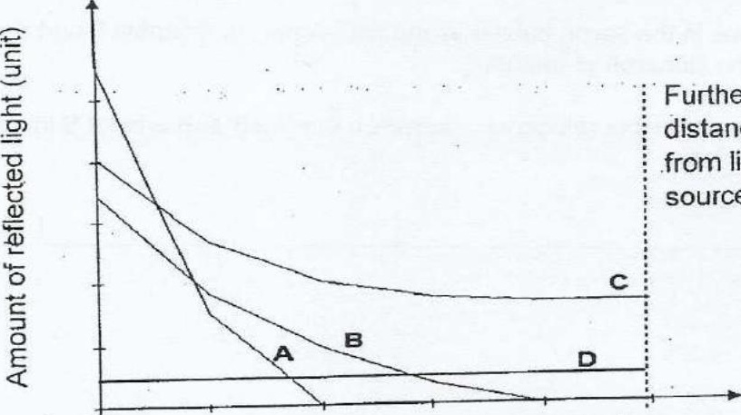

; Furthest  
  
; distance away  
: from light  
  
‘+ source

Distance away from light source (m)

Question 35 is continued on page 41