Downloaded trom www.singapore-exam-papers.com

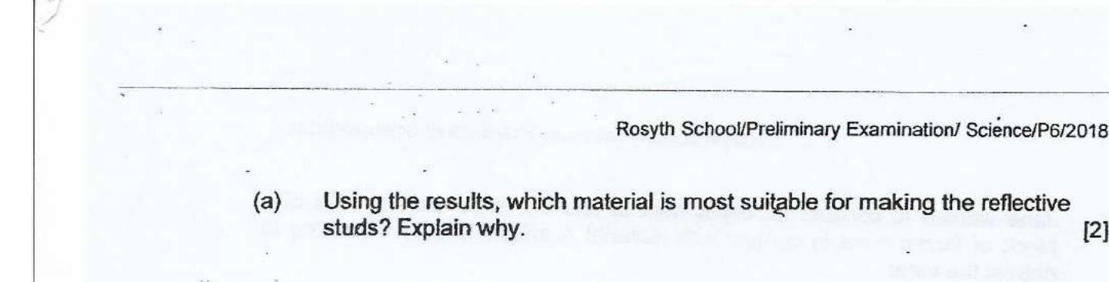



(b) Draw the pathway of light using arrows (——+) to show how light travels to  
enable driver of a car to see the lit reflective stud on the road in the diagram  
below. - [1]

