Downloaded trom www.singapore-exam-papers.com

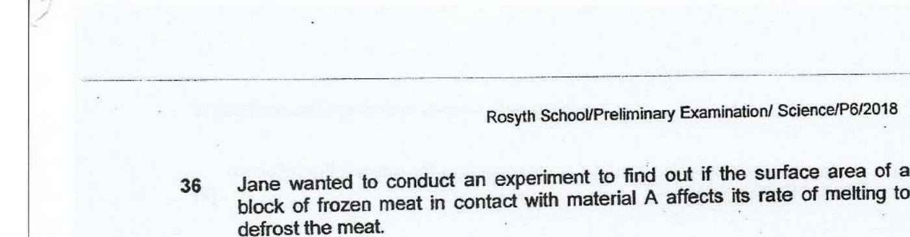



In her experiment, she used two similar frozen meat blocks and two similar  
  
trays of Material A. Material A is a good conductor of heat. She left both set-  
  
ups by the window and recorded the time taken for each frozen meat block to  
defrost completely. .

The possible set-ups of her experiment are shown below.

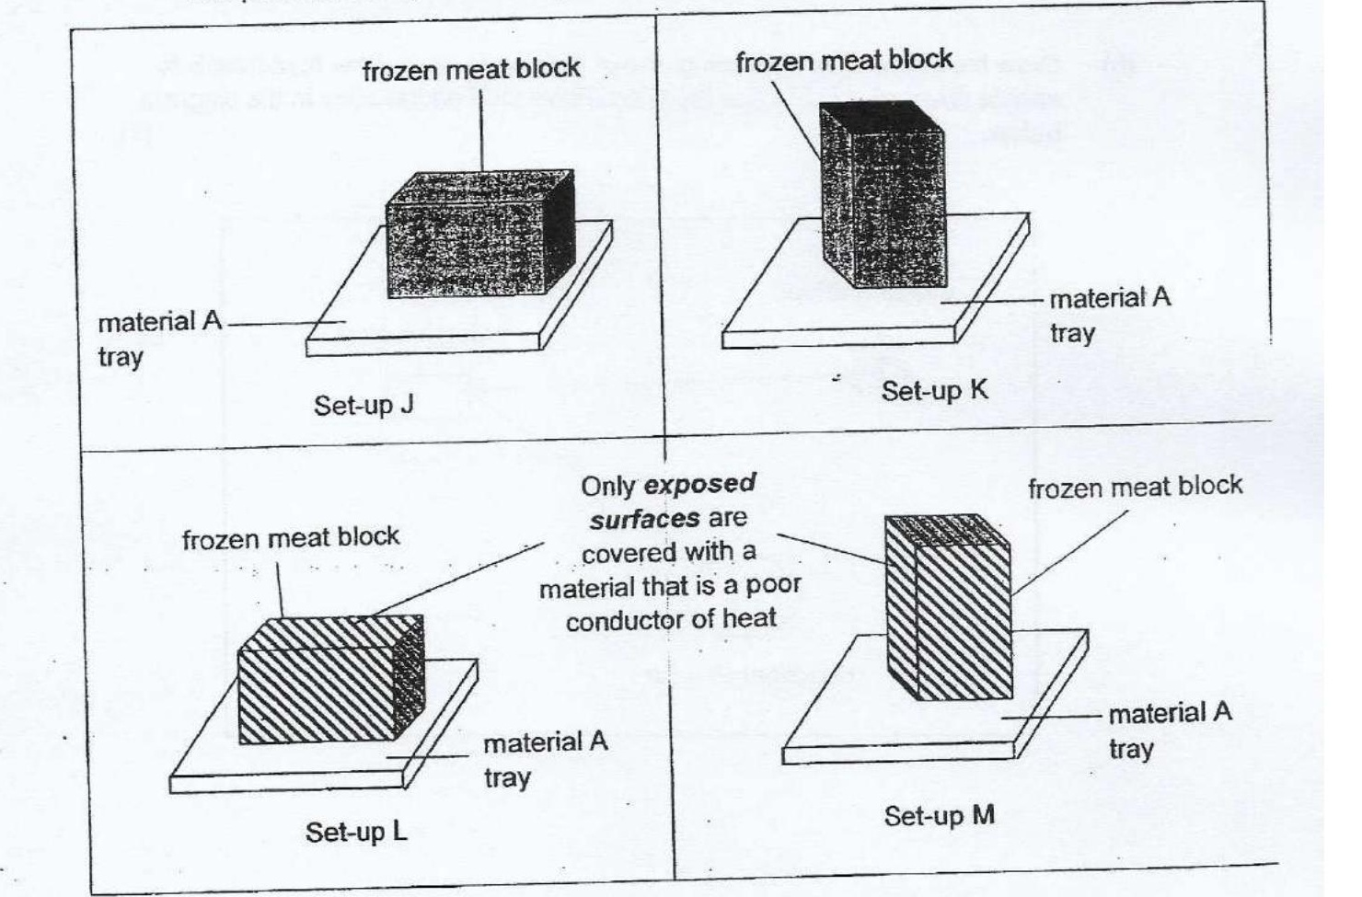

(a) Which two set-ups, J and K or L and M should Jane use to carry out a fair  
experiment? {1]



Question 36 is continuedon page 13