Downloaded trom www.singapore-exam-papers.com

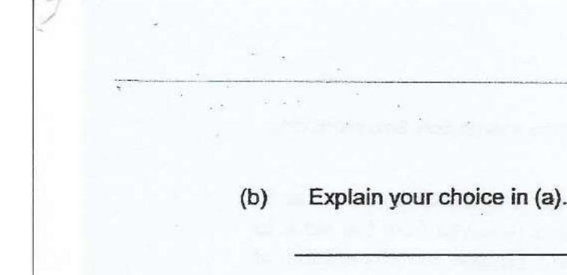



(c) Suggest a material that can be used to cover the exposed surface areas of  
frozen meat blocks in sef-ups L and M.

(d) Jane then carried out another experiment to determine how well heat is  
conducted through tray materials A and B. She obtained the results as shown  
\* in the table below. :

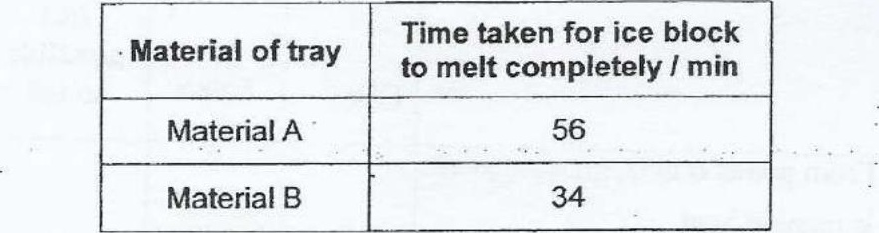

Based on the results shown above, what conclusion can Jane make about now  
materials A and B conduct heat? 11]