Downloaded trom www.singapore-exam-papers.com

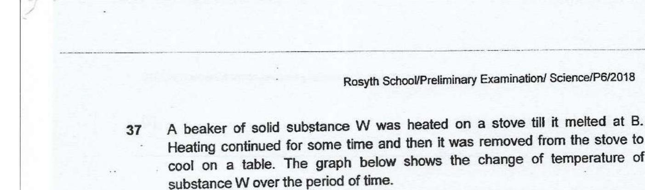



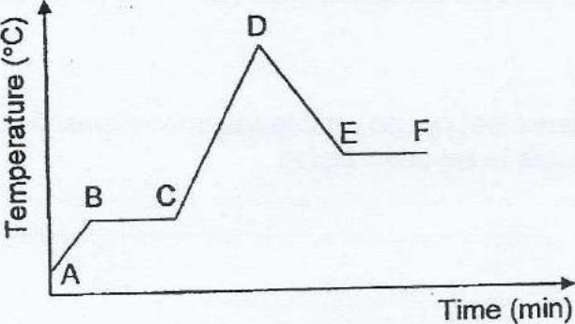

Based on the information above, put a tick (¥) in the correct box for each

