Downloaded trom www.singapore-exam-papers.com





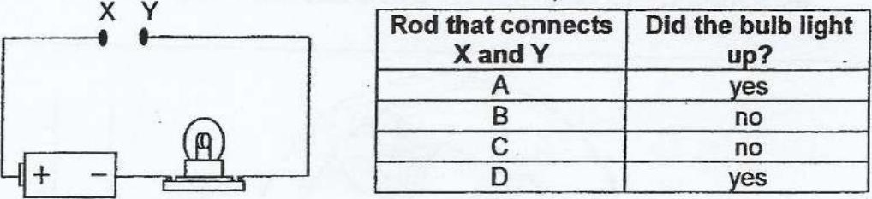

In another experiment, the same four rods A, B, C and D were piaced at  
different positions $1, $2, S3 and S4 in the following circuit.

