Downloaded trom www.singapore-exam-papers.com

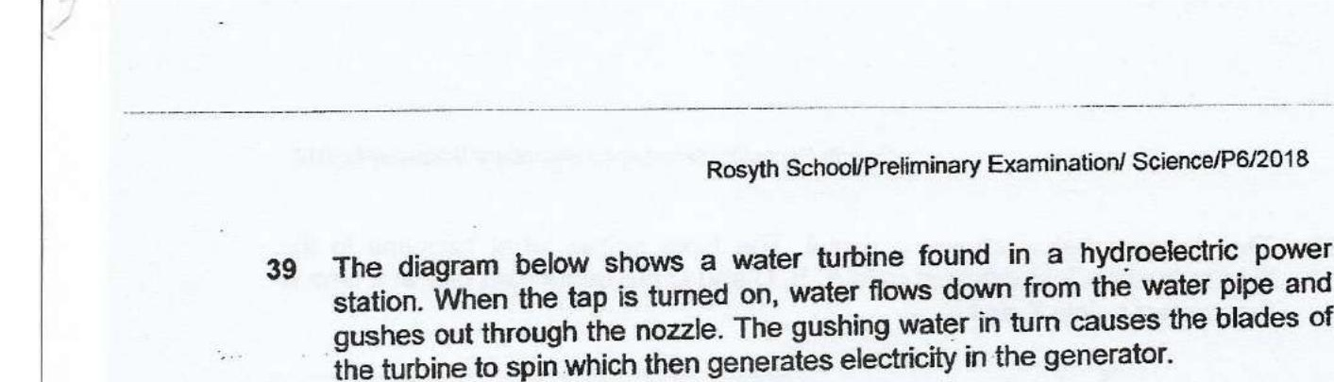



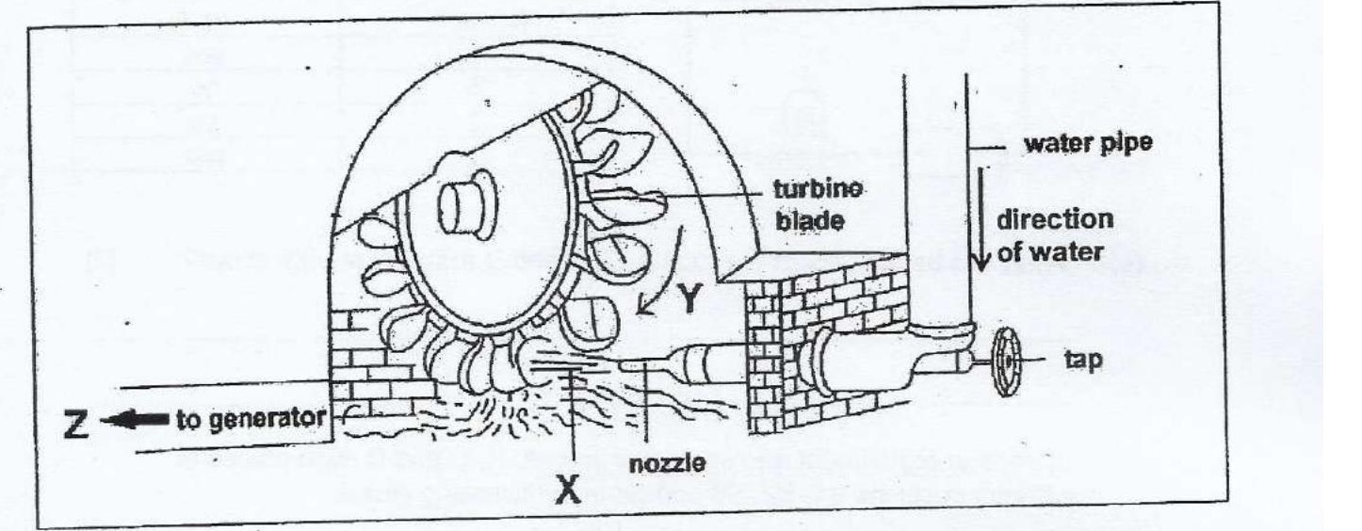

(a) State the useful energy changes that take place in the set-up above to generate  
electrical energy. (1}



(b) Draw the graph to show the relationship between the speed of water (unitimin)  
that passes through the pipe and the rate of spinning turbine (unit/min). {1}

