Downloaded from www.singapore-exam-papers.com

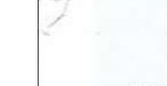

40 The diagram below shows a floating dining table.

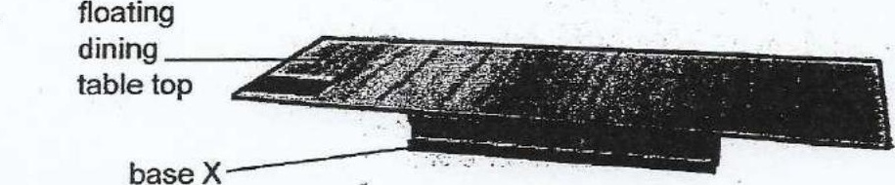

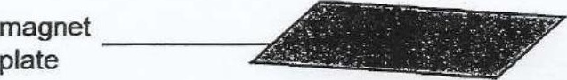

The floating dining table consists of a magnet plate on the floor and a special  
base X. Base X must be present in order for the table top to float.

(a) loaentity what base X Is.

(b} Describe how the dining table is able to float.

It is not recommended to place items with a total mass of greater than 150kg  
on the table top as it will not be able to float.

(c) Why does the dining table not float when the mass piaced on if Is greater than  
150 kg? (1)

(d) Suggest a way that would allow the table top to float while holding items with a  
mass greater than 150kg. :

