Downloaded from www.singapore-exam-papers.com

nttps://www.singapore-exam-papers.com





LEVEL \* PRIVIARY 6







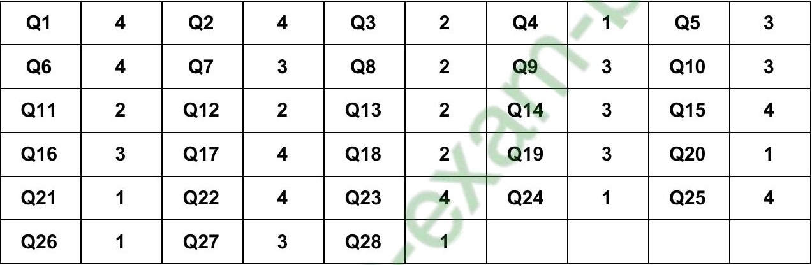





Q295) Place M may have contained more moisture than Place N, causing the leaves to  
decompose faster, hence the difference in mass of dead leaves in both places.

lose the water, and the mass of it.

