Downloaded trom www.singapore-exam-papers.com

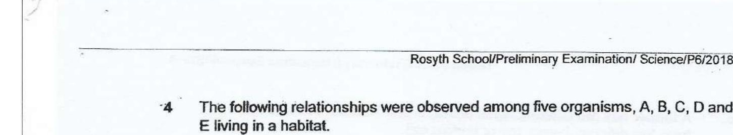



C feeds on A, B and D.  
B feeds on A.  
FE feeds on C.

Which one of the following is correct?

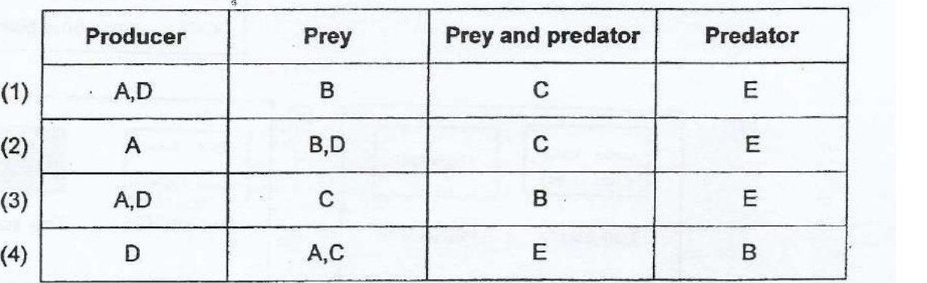

5 The diagram below shows a rotting log.

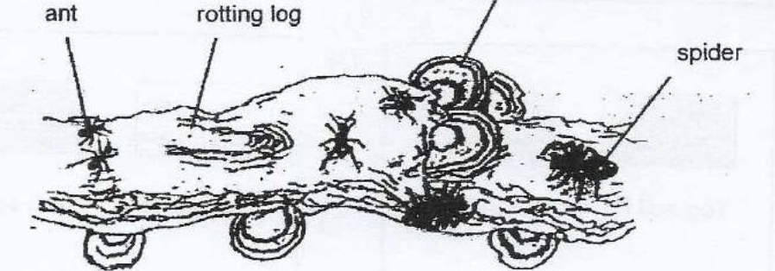

(1) The population size of the fungus Is two.  
  
(2) The rotting log is an example of a single plant population.  
  
(3) There is only one population of insect living on the rotting log.  
(4) There are two populations of organisms living on the rotting log.