Downloaded from www.singapore-exam-papers.com

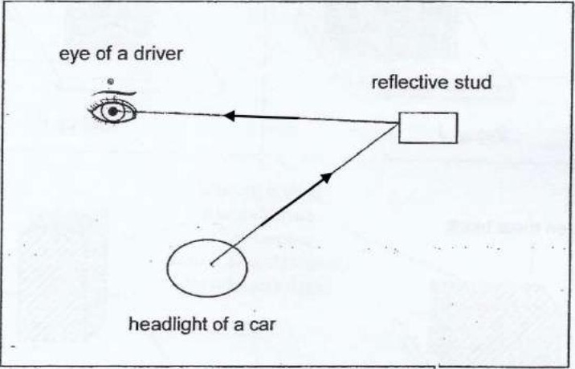



Q36b) By choosing both set-ups, the only variable affecting the result is the surface area  
of the block in contact with A. The exposed surface areas are covered with a poor

conductor of heat to ensure most heat gain is largely due to the surface area in contact  
with A. This perfectly represents the objective.







b: Not possible to tell

