Downloaded from www.singapore-exam-papers.com

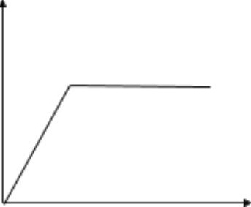

Q40a) Magnet

Q40b) Base X is a magnet with its like poles facing the magnet. Since like poles repel,  
base X was repelled by the magnet plate, and the magnetic force is stronger than the  
gravitational pull, allowing the table to float.

Q40c) When 150kg is added to the table, the magnetic force is unable to overcome the  
gravitational pull as the gravitational force has increased due to additional mass.