Downloaded trom www.singapore-exam-papers.com

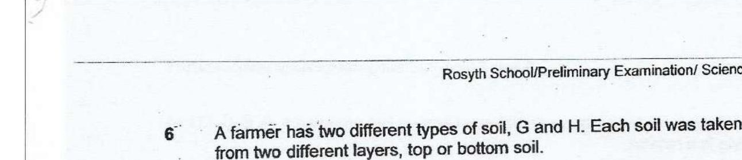



He predicted that plants will grow more healthily in soil G while his friend -  
_ predicted that plants will grow more healthily in the top soil of soil H. .

Which of the following set-ups should the farmer use to provide a correct test  
for both their predictions? :

