Downloaded trom www.singapore-exam-papers.com



(1) OW spl  
  
(2) Soil erosion _  
(3) Deforestation  
  
(4) Global warming

8 Dennis wanted to find out if plant takes in water through its roots.  
Which one of the following should Dennis use as an experimental set-up?

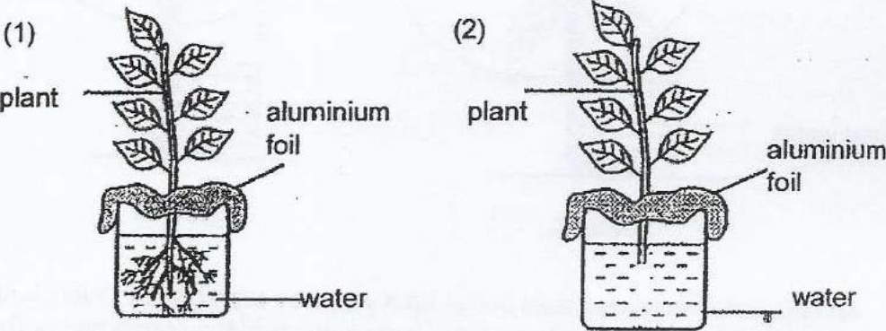

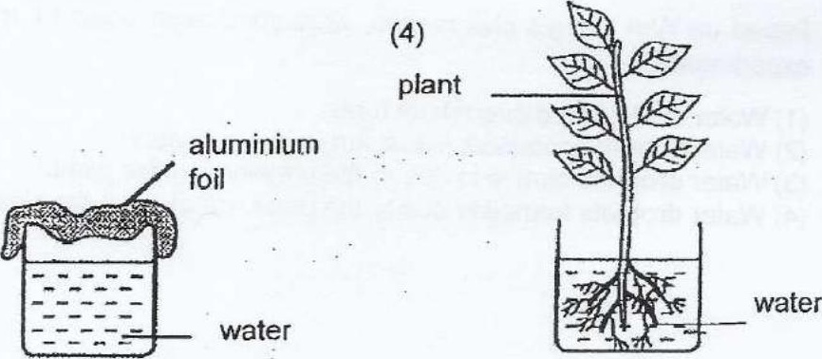

9 YVhat Is the function of cytoplasm in animal cell’?

(1) Controls cell activities  
  
(2) Controls inheritance from one generation to another  
  
(3) Controls the movement of substances within the cell  
  
(4) Controls the movement of substances in and out of the cel!