Downloaded trom www.singapore-exam-papers.com



40 Wei Liang prepared two set-ups, X and Y for an experiment. In Set-up %, he  
put a plant into a container of red coloured water and covered the plant with a  
plastic bag. In Set-up Y, he replaced the plant with a stick instead and covered  
it with a plastic bag. The two set-ups were placed in the same location.

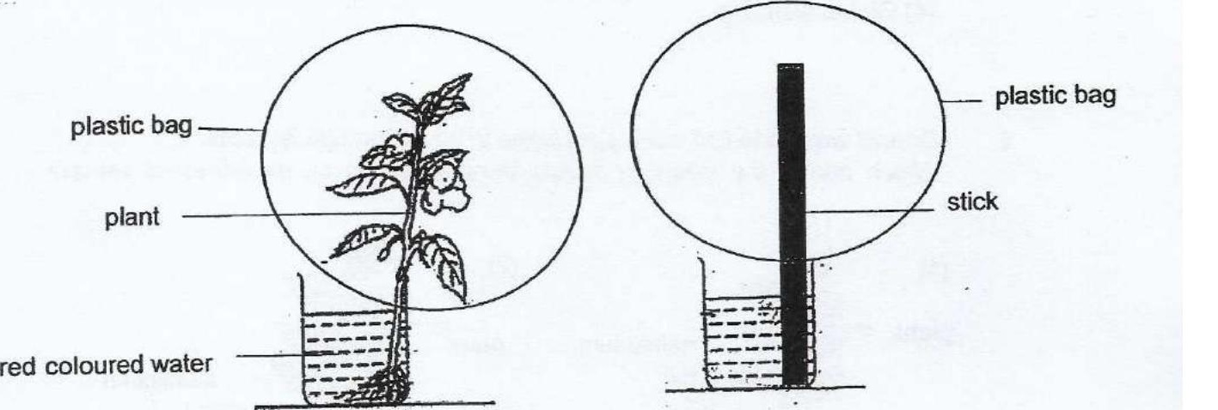

An hour later, the water level in Set-up X was less than before. Wel Liang  
also found tiny water droplets on the inner surface of the plastic bag in Set-up  
X but not in Set-up Y.

Based on Wei Liang’s observation, what conclusion could he make from his  
experiment?

(1) Water is absorbed through its roots.  
_. + ».(2)-Water in both containers is lost through evaporation. .  
. (3) Water dropiets formed is due to the presence of the plant.  
(4) Water droplets formed is due to the presence of air in the plastic bag.