Downloaded trom www.singapore-exam-papers.com

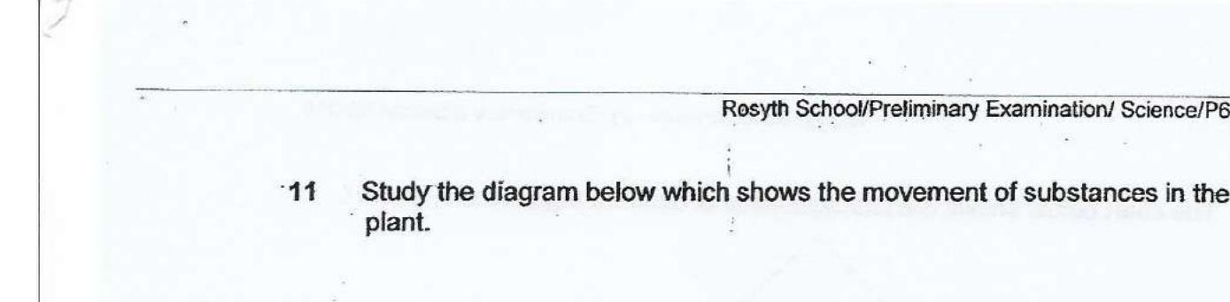



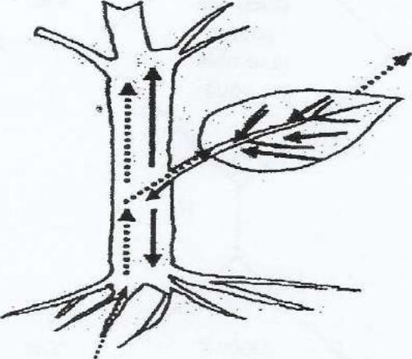

Vvhich one of the following shows the correct movement of substances In the  
plant?

