Downloaded trom www.singapore-exam-papers.com

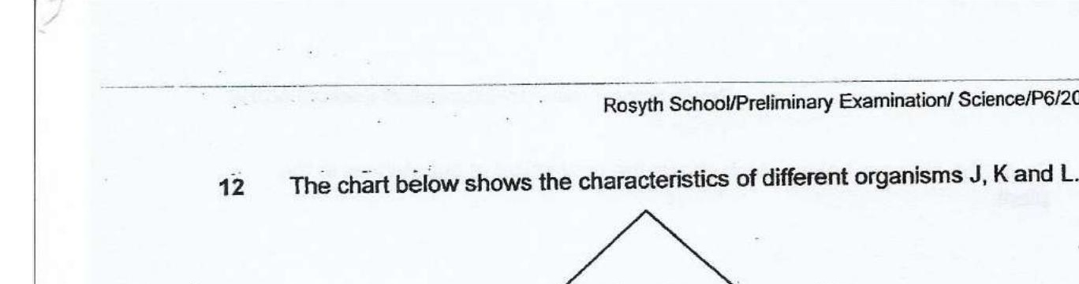



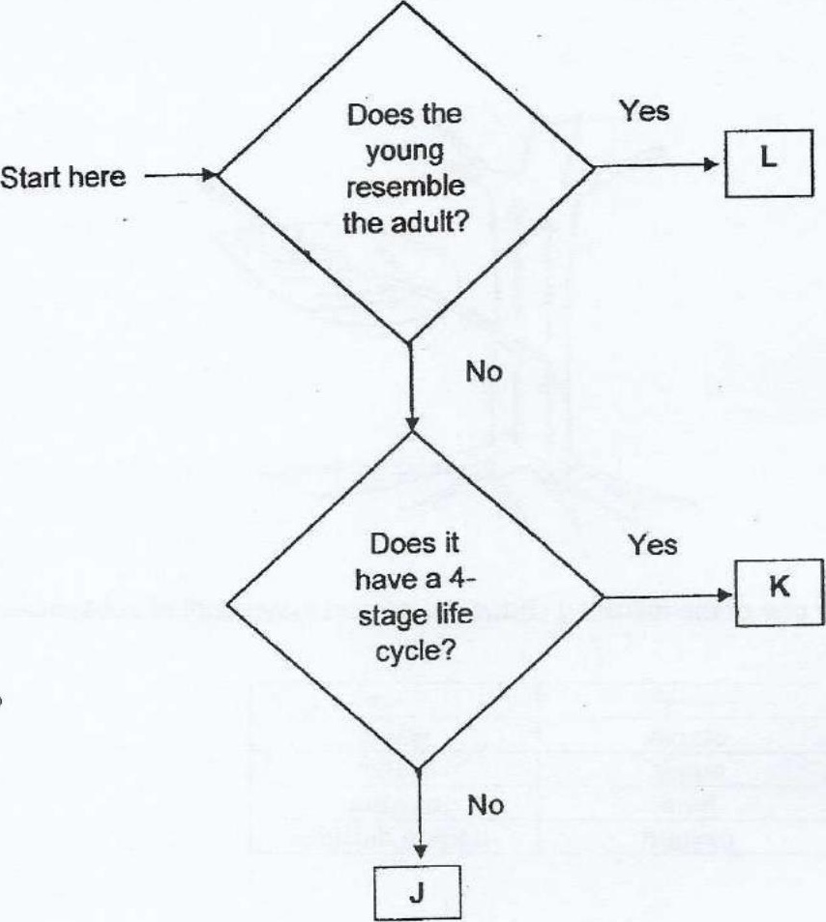

Which of the following represents the life cycle of organisms J, K and L?

