Downloaded trom www.singapore-exam-papers.com

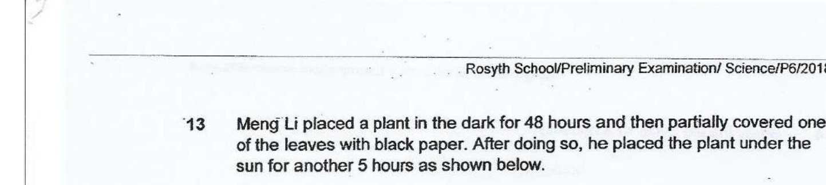



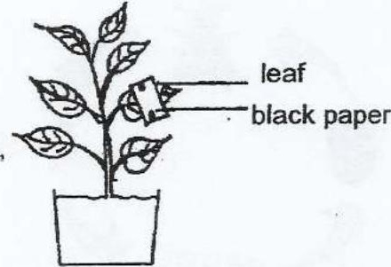

He tested the leaf for starch by using fodine solution and observed the leat as  
shown below.

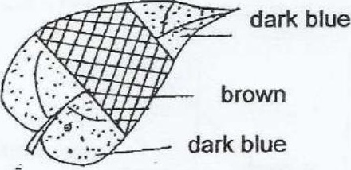

A: Air is needed for photosynthesis.  
. B: Sunlight is needed for photosynthesis.  
_C: Chlorophyll is needed for photosynthesis oo

_. (1) A only  
, (2) B only  
(3) B and C only  
(4) A, Band C