& VY  
Le ES \*

CATHOLIC HIGH SCHOOL  
MID-YEAR EXAMINATION (2019)  
PRIMARY SIX  
ENGLISH LANGUAGE

PAPER 2 (LANGUAGE USE AND COMPREHENSION)

BOOKLET B

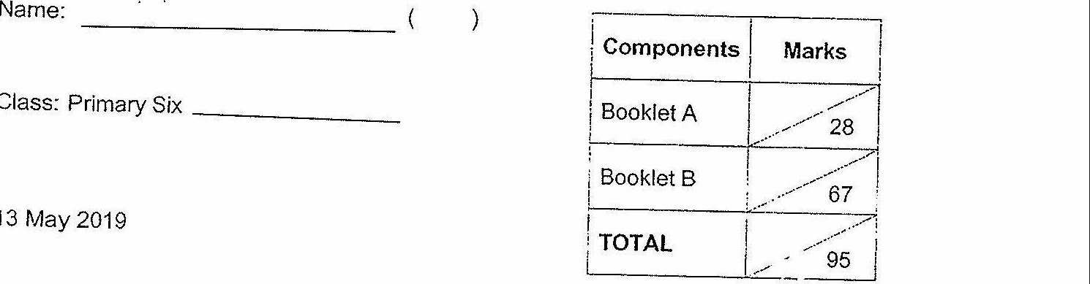

Class: Primary Six

13 May 2019

02 Questions  
(67 Marks)

Parent's  
Signature: ee

Total Time for Booklets A and B: 1 hour 50 minutes

INSTRUCTIONS TO CANDIDATES

Do not open this booklet until you are told to do so.

Follow all instructions carefully.

Answer ali questions.

Write your answers in this booklet.

This booklet consists of 8 printed pages excluding the cover page.