There are 10 blanks, numbered 29 to 38, in the passage below. From the list of words  
given, choose the most suitable word for each blank. Write its letter (A to Q) in the  
blank. The letters (I) and (O) have been omitted in order to avoid confusion during  
marking. (10 marks)

FACH WORD CAN BE USED ONLY ONCE.

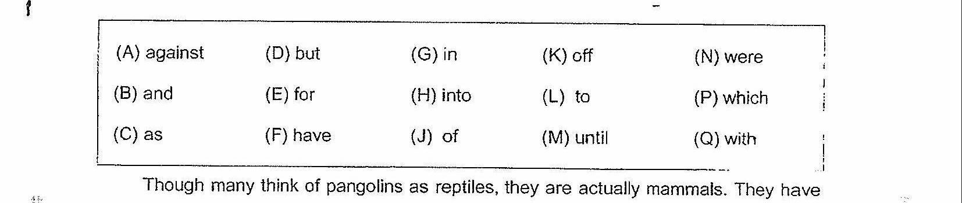

jarge protective keratin scales covering their skin and are the only known mammals |

(29) this feature. With its foreciaws hanging just (30) the |

ground, it looks like a miniature T-rex (31) it ambles along on its hind legs. |

The scaly mammal’s formidable foreclaws are built not for walking, (32) for |

ripping open ant hills and termite nests.

When in danger, it may curl (33) a ball, relying on its armour of scales |

tO protect Its conical head and delicate underbelly. Unfortunately, that armour is no protection |

(34) cars travelling at high speed.

Hunched close to the ground, the pangolin is hard (35) any driver to |

spot on the road. If it is caught (36) the headlights of a vehicle, the shy |

creature may freeze, and even when fleeing, it can only rev up (37) aman’s |

Jogging pace.

According to the National Parks Board (NParks), an average of two pangolins a year |

were found dead on major roads around the Bukit Timah and Central Catchment nature |

reserves from 1994 to 2014. That number may not seem a lot (38) one |

realises that the total number of wild pangolins in Singapore may be just more than 50.

in Singapore, it is illegal under the Wild Animals and Birds Act to remove pangolins. |

trom the wild. Those found in nature reserves are also protected by the Parks and Trees Act |

Adapted from hitps-//graphies. straitstimes. com/STVSTIMEDIA/Interactives/2015/1 t/feature- |  
ecolink-BKF -national-narks/