Each of the underlined words contains either a spelling or grammatical error. Write the  
correct word in each of the boxes. {12 marks)

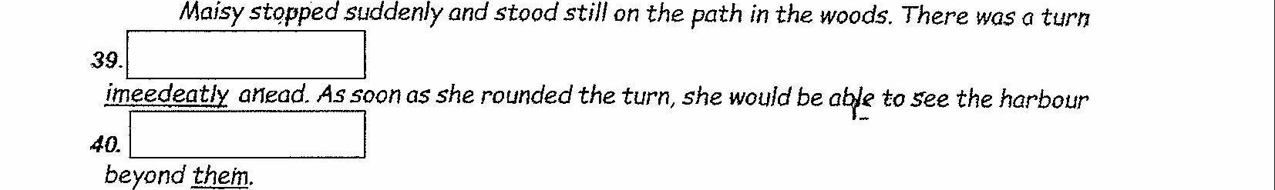

af |  
However, she heard something else. She was certain it was not her imagine. She

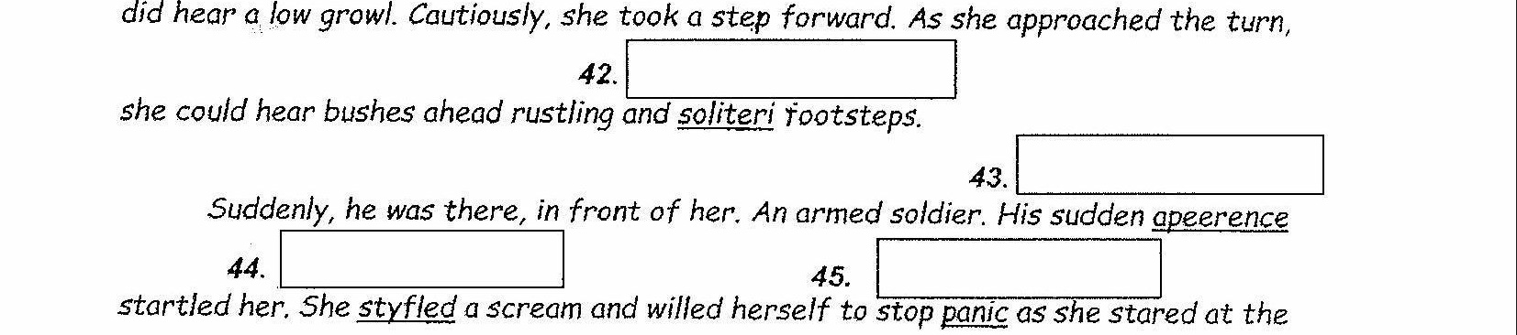

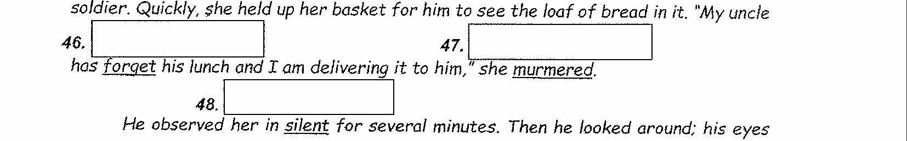

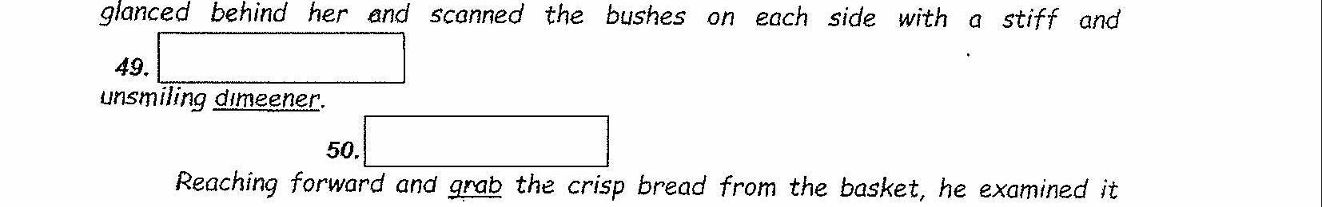

closely. Then he broke it in half, pulling the two halves apart with his fists.

|

Adapied trom ‘Number the Stars’ by Lois Lowry