75. Based on lines 12~20, fill in the following table. (2m)

What Johnson thought | What actually happened  
ee  
When Johnson saw  
the board  
' -

/8.LOoK at the table below. What do the words in the left column refer to in the passage?  
Write your answers in the column on the tight. (3m)

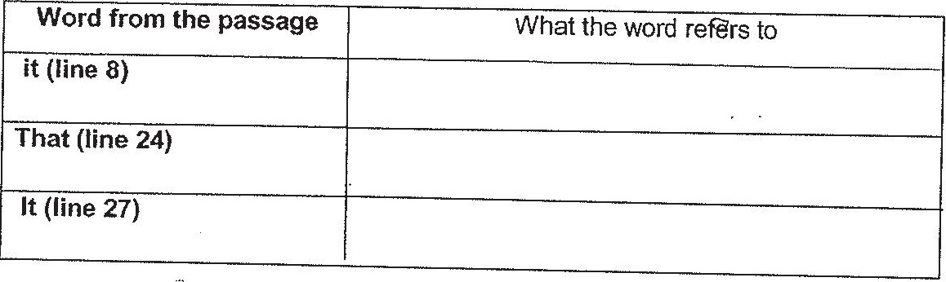

(?. Write 1, 2 and 3 in the blanks below to indicate the order in which the events occurred in  
the story. [1m]

Jonnson was attacked by the spider.

vonnson turned around and saw the spider.

Jyonnson tried to look fora way out of the banrn.