78.Based on the siory, state whether each statement in the table below is true or faise, then  
give one reason why you think so. [3m]

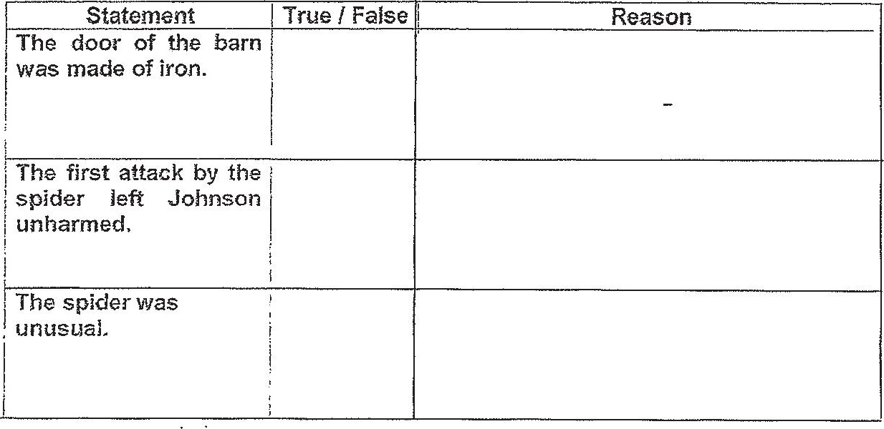

79.Jonnson did not run trom the spider. Choose two traits of the spider that made Johnson  
stay stil id not run from it. Put a tick (¥) in the box beside each of your answers. [21a]  
DO NOT TICK MORE THAN TWO BOXES.

| huge | [ athletic  
  
2 | TNS  
ne be —_— |  
alert : | | swift | |  
| , ! | |  
| careless : | cautious | —  
| _ dt a ee

80. When ‘Jonnson said, ‘Let me have another go at it.’ (line 42), what do you think he  
intended to do? Why da you think he said that? [2m]

tha EPSP PPP PP spy rssh rere

<ND OF PAPER