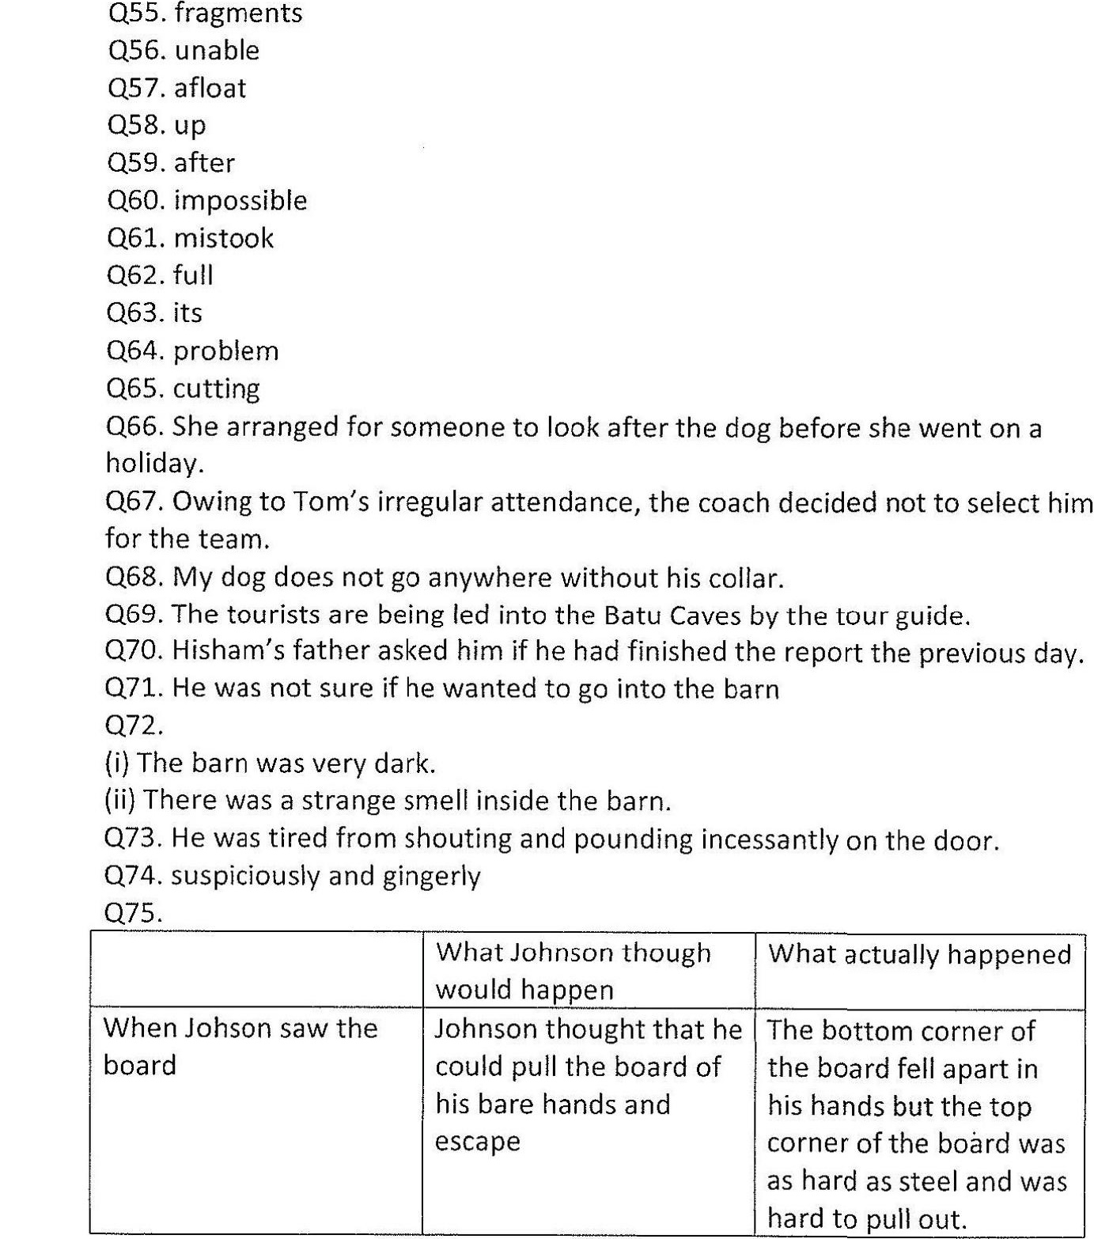

Q/6.  
(i) it (line 8 )- shouting and pounding incessantly on the door  
(ii) That (line 24)- when the board did not move  
(iii) ‘It (line 27)- the spider  
  
Q77.2,3,1