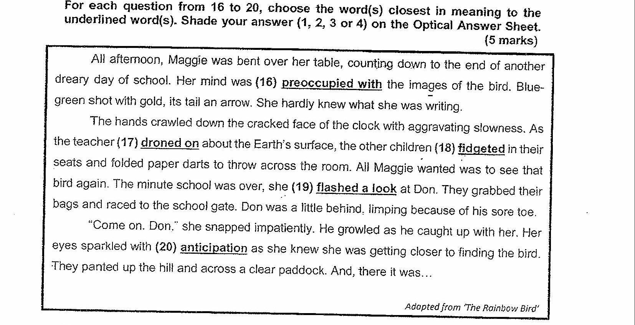

16. (1) oblivious to  
(2) confused by  
(3) enriched with  
(4) consumed by

17. {1) — spoke softly  
(2) spoke loudly  
(3) spoke monotonously  
(4) spoke enthusiastically

16. (1) quivered  
(2) slumped  
(3) squirmed  
(4) shuddered

19. (41) ~~ glared  
(2) glanced  
(3) squinted  
{4) scrutinised /

40. (1) hope  
(2) affection  
{3) impatience  
{4) apprehension