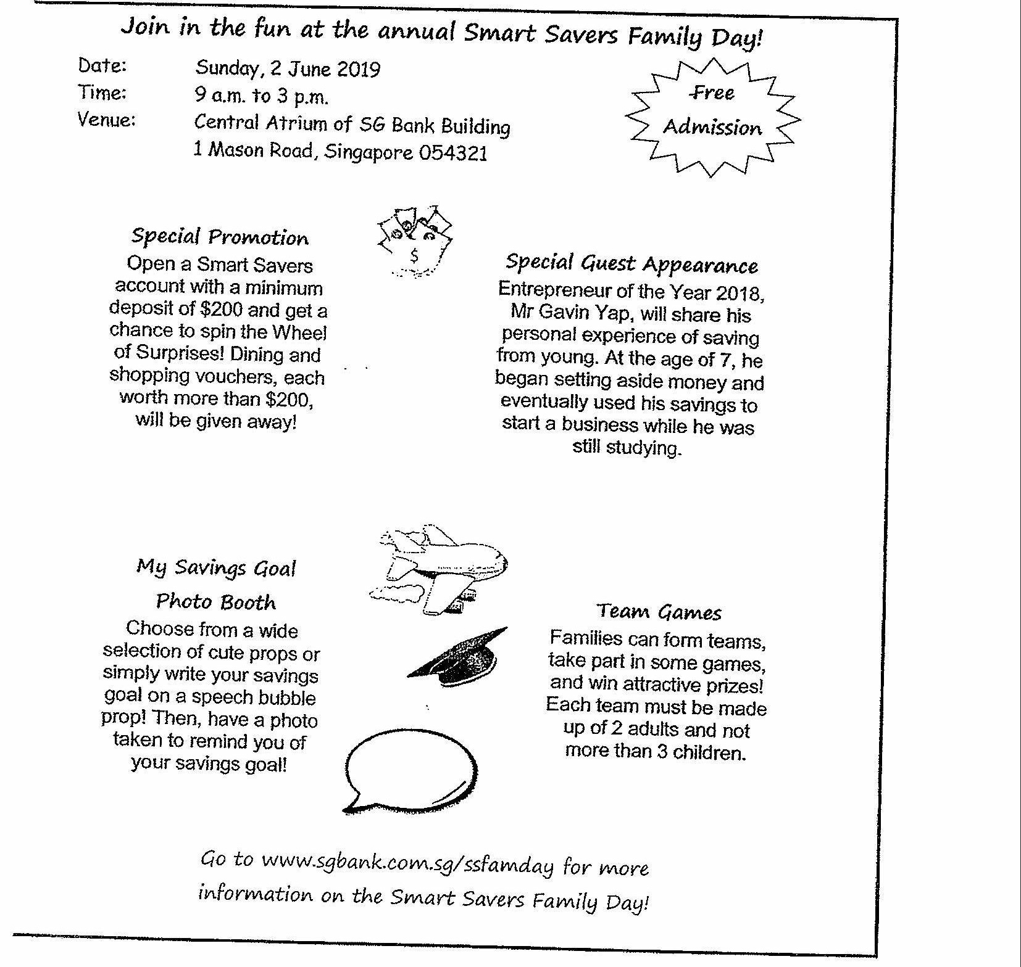

Go to www.sgbank.com.sg/ssfamday for more  
information on the Smart Savers Family Dau!