Each of the underlined words contains either a spelling or grammatical error. Write the  
correct word in each of the boxes. (12 marks)

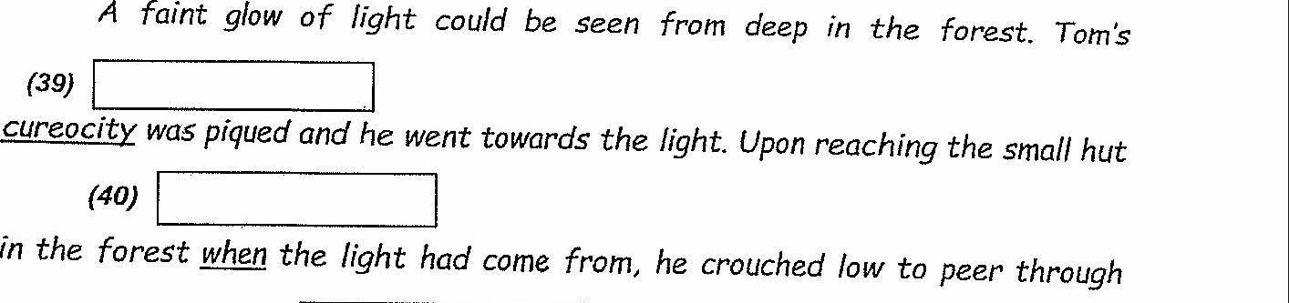

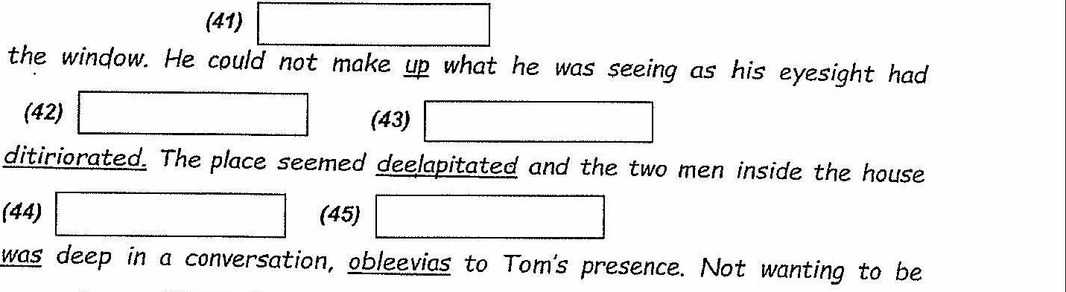

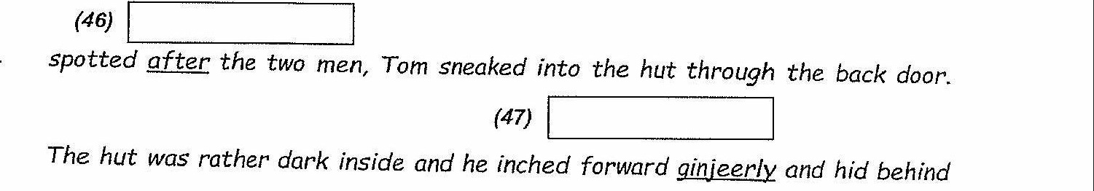

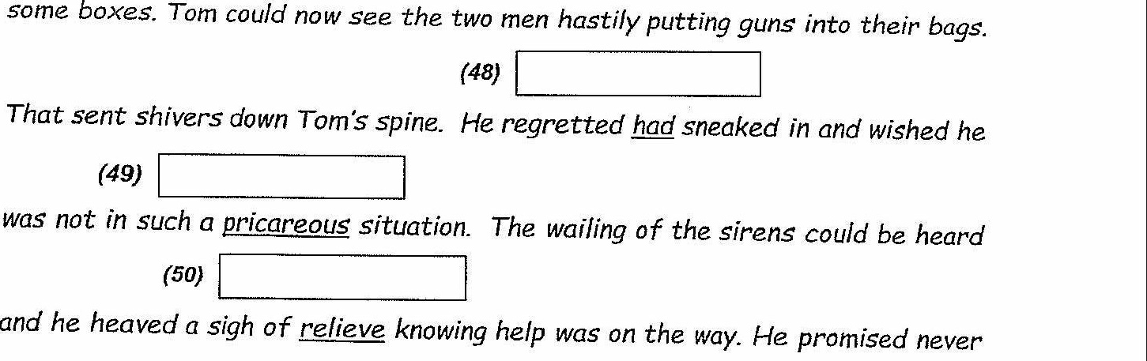

to venture out on his own again in the future.

Score: 112  
(Go on to the next page)