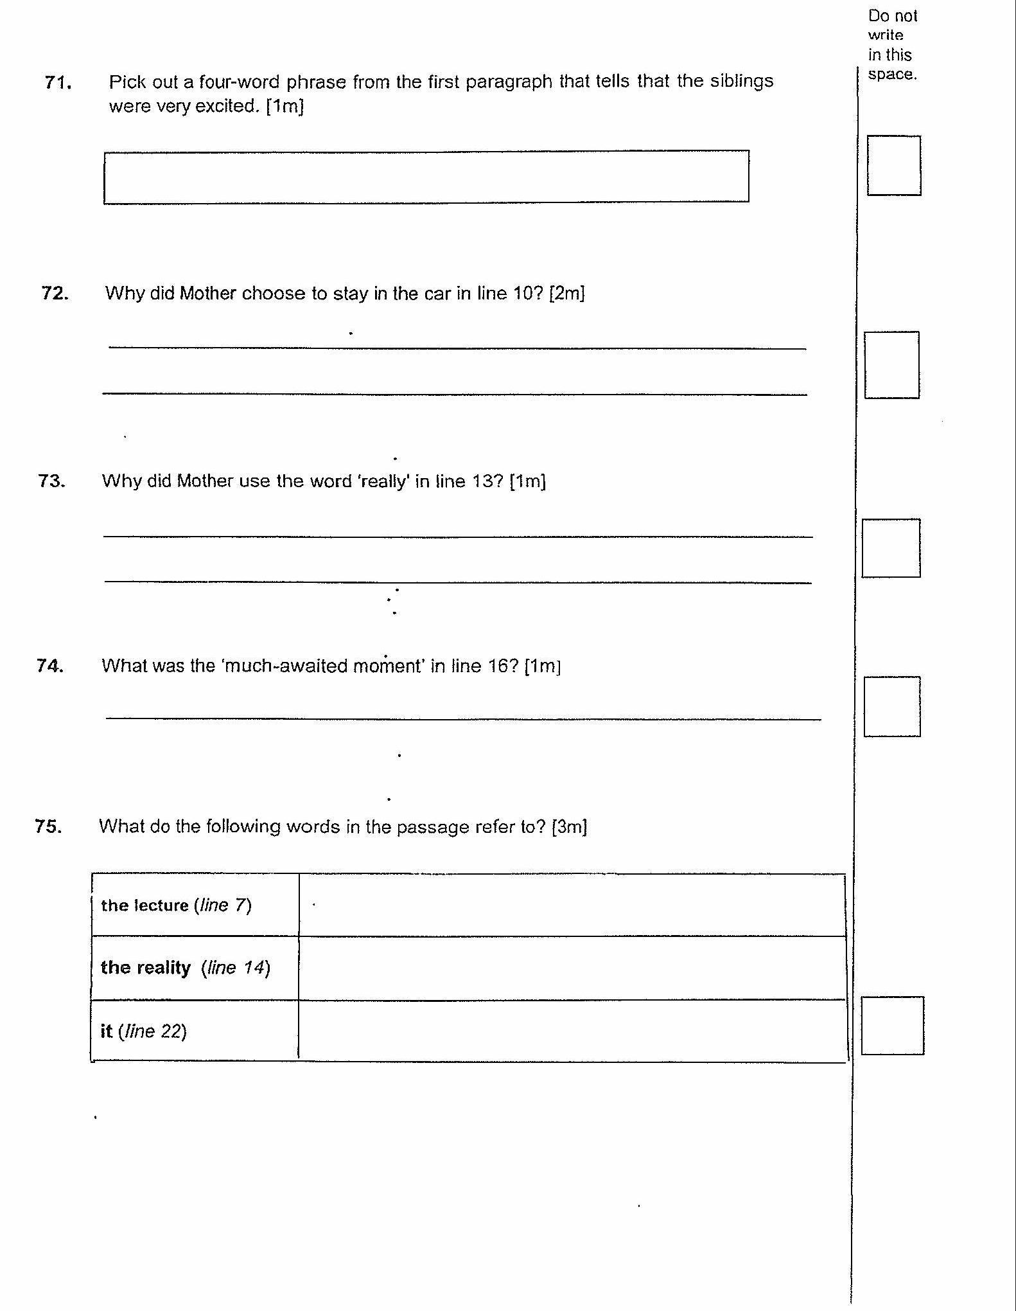

72. Why did Mother choose to stay in the car in line 10°? [2m]

73. Why did Mother use the word ‘really' in line 137 [1m]

74. What was the ‘much-awaited moment’ in line 16? [1m]

75. What do the following words in the passage refer to? [3m]

(Go on ta the next page) |