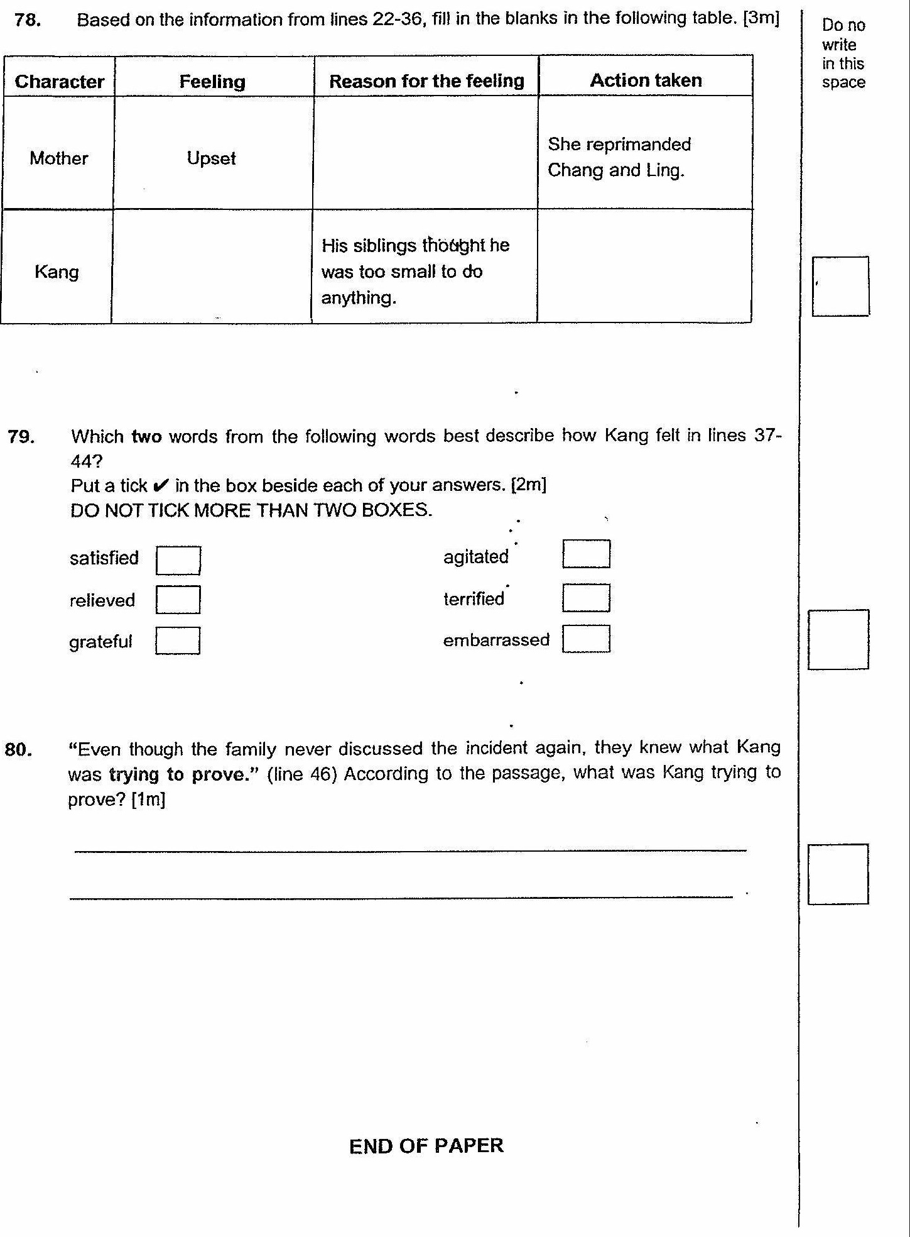

satisfied | |  
relieved [|  
grateful r |

-ND OF PAPER