ANSWER KEY

YEAR : 2019  
  
LEVEL : PRIMARY 6  
  
SCHOOL : MARIS STELLA HIGH SCHOOL (PRIMARY)  
SUBJECT : ENGLISH  
  
TERM « SAT

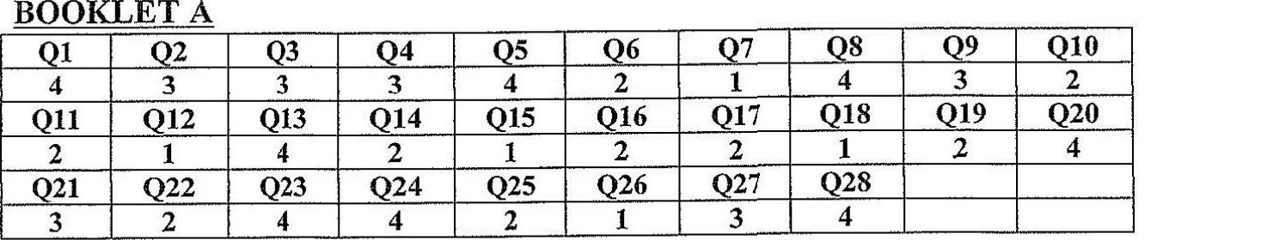

BOOKLET B  
929 T_Q30 [31 | Q32 [933 | 034 7 935 | 036 [ 037 | 938 |  
p | vs to | bp | Nn if Af Cc | wf F [TL

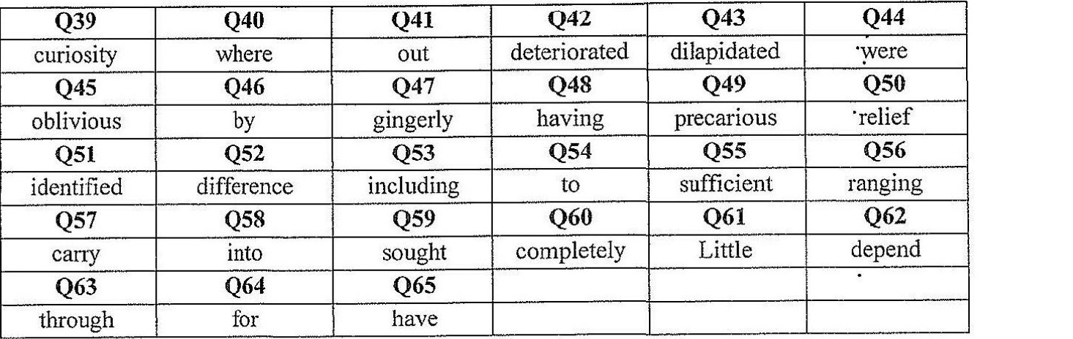

Q66 We cannot use the sports equipment unless the teacher gives us permission.  
067 It was with reluctance that Sandra attended her ballet class.

Q68 Due to her diligence, her results improved tremendously.

Q69 Wading in the river, the duck was attacked by a water snake.  
O70 Ms Elnie said that she had drawn that picture the previous year.

O71 bouncing off the walls.  
O72 Mother saw that the ground was maddy and she did not want to dirty her sparkling

073 Mother was shocked that they actually adopted a dog.

O74 QOne-eyed finally arriving.