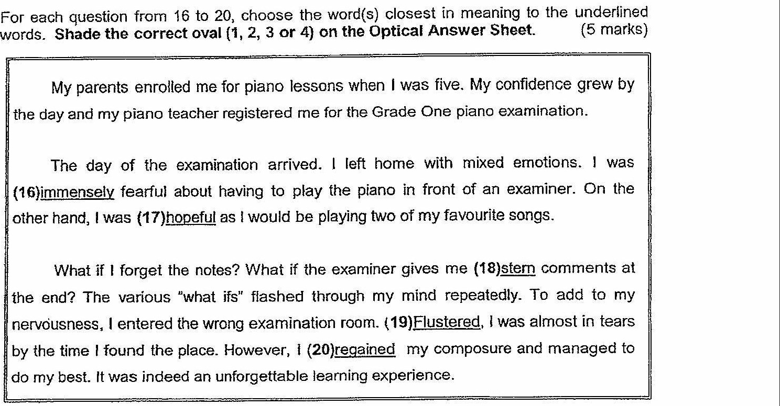

16. (1) densely  
{2) extremely  
(3) frequently  
(4) continually

17. (4) convinced  
(2) optimistic  
(3) fortunate.  
(4) anxious

i8. = (1} harsh  
(2) difficult  
(3) dangerous  
(4) threatening

19. (7) Batiled  
(2) Agitated  
(3) Distraught.  
{4) Distracted

20. (1) rejoined  
{2) retrieved  
(3) reclaimed  
{4) recovered

4 (Go on to the next page) |